CHAPTER 1: INTRODUCTION

1.1 Background

1.1.1 Global Context
Women's safety and empowerment have become pressing global concerns as gender-based violence, workplace inequity, cyber harassment, and restricted access to legal and psychological support continue to affect women across both developed and developing societies. Worldwide, roughly one in three women experience physical or sexual violence in their lifetime, and the growth of smartphone and social-media use has extended this harm into digital spaces: online harassment, cyber-stalking, non-consensual image sharing, and cyber-blackmail have all risen alongside internet connectivity.
A wide range of digital interventions has emerged in response. Emergency-alert and location-sharing tools such as bSafe and Noonlight give users a one-touch way to notify trusted contacts, building on earlier research into mobile-enabled emergency alerting in urban environments [19]. Data-driven initiatives such as Safetipin generate crowd-sourced safety scores for public spaces, supporting preventive route planning rather than only reactive response. In parallel, machine-learning research has advanced automated detection of abusive language: Support Vector Machine and related classifiers have been shown to reliably flag cyberbullying in social-media text [10], and youth-focused tools such as ReThink apply natural language processing to intercept harassing messages before they are sent [22]. A separate line of digital mental-health tools — Cognitive-Behavioural-Therapy-based chatbots such as Woebot, and peer-support services such as 7 Cups — has shown that technology can lower the practical barriers to seeking emotional support.
Despite this progress, a recent systematic review of women's safety applications published between 2023 and 2025 found that most commercial and research solutions still centre on a narrow set of reactive features — SOS alerts, GPS tracking, and geofencing — rather than an integrated, preventive ecosystem that also covers legal, psychological, and economic needs [12]. Harassment-detection research, in turn, remains concentrated in English-language, high-resource settings, leaving most of the world's linguistically diverse populations with little or no automated protection.

1.1.2 The Sri Lankan Context
In Sri Lanka, women face a dual burden of traditional and technology-mediated risk. Sri Lanka's first dedicated national survey on violence against women and girls, the 2019 Women's Wellbeing Survey, conducted by the Department of Census and Statistics with UNFPA support [9], found that one in five ever-partnered women (20.4%) had experienced physical and/or sexual intimate-partner violence in their lifetime, and that almost one in four women (24.9%) had experienced physical and/or sexual violence by a partner or non-partner. The same survey found that most women who experienced violence never reported it to police: only 25.3% of those who spoke to anyone about their experience reported it to the authorities, and 21.4% of women who experienced partner sexual violence told no one at all before being surveyed.
Legal protections exist on paper — including provisions addressing domestic violence and cyber offences — yet stigma, limited legal literacy, and fear of retaliation deter many women from using them. Recourse is therefore typically limited to hotlines, police reports at stations such as the 119 emergency line, visits to Women and Children's Units, or NGO intervention: mechanisms that are inherently reactive rather than preventive, and that depend on a woman being willing and able to come forward in person.
Sri Lanka's own digital-safety landscape remains narrow. 2six4, developed by Women In Need (WIN), enables rapid communication with trusted contacts, police, or hospitals during emergencies, particularly in cases of public-transport harassment and gender-based violence. Cyber Care, developed with UNDP support, targets cyber violence and harassment among youth and women. Fio provides trilingual women's health services, including menstrual-cycle management and access to health professionals. Each is valuable within its own remit, but — as Table 1.1 illustrates — none integrates AI-based harassment detection, encrypted evidence storage, anonymous legal guidance, mental-health support, and economic empowerment into a single platform, and none is built on NLP models trained for Sinhala or Tamil.
Table 1.1: Feature comparison of existing Sri Lankan women's-safety applications and the proposed platform
Feature | 2six4 (WIN) | Cyber Care (UNDP) | Proposed Platform
Emergency SOS / location sharing | Yes | No | Yes
AI cyber-harassment detection | No | Partial | Yes (Sinhala/Tamil/English)
Encrypted evidence vault | No | No | Yes
Anonymous legal chatbot | No | No | Yes
Mental-health support | No | No | Yes
Economic empowerment / jobs | No | No | Yes

International digital-safety solutions are similarly fragmented when viewed against Sri Lanka's specific needs: they are rarely adapted to Sri Lanka's legal framework, trilingual population (Sinhala, Tamil, English), or cultural context, and sophisticated features such as AI-driven harassment detection, encrypted evidence storage, and anonymous legal advice remain largely unavailable on Sri Lankan platforms. This thesis addresses that gap by designing, developing, and evaluating an AI-integrated digital platform built specifically for women in Sri Lanka — one that treats safety, legal access, mental health, and economic empowerment as a single, connected problem rather than a set of separate applications.

1.2 Problem Statement
There is currently no system in Sri Lanka that offers safety, legal, psychological, and economic support to women through a single, secure, AI-enabled digital platform. Existing local applications such as 2six4, Cyber Care, and Fio each address an isolated dimension of the problem — emergency communication, cyber-harassment reporting, or reproductive health respectively — but none integrates AI-based harassment detection, encrypted evidence storage, anonymous legal guidance, mental-health screening, and an employment-oriented empowerment layer into one coherent system. This fragmentation forces women to move across multiple disconnected services at the exact moments when they are least able to do so, and national survey data confirm the cost of that fragmentation: the majority of Sri Lankan women who experience violence never report it to police, citing embarrassment, fear of not being believed, fear of blame, or simply not knowing what options exist [9].
The absence of localized natural language processing (NLP) models compounds the problem. Most existing harassment- and hate-speech-detection research has been built and validated on English-language, Western-context datasets, leaving Sinhala- and Tamil-speaking users with little to no automated protection. Where Sinhala-language work does exist, it is limited in scale — the most widely cited Sinhala hate-speech corpus contains only around 3,000 annotated Facebook and YouTube comments [26] — and comparable Tamil resources remain similarly constrained, despite Tamil being spoken by more than 70 million people globally [16].
The research problem this thesis addresses is therefore twofold: (1) a systemic gap in integrated digital support for women's safety, legal access, mental health, and economic empowerment in Sri Lanka, and (2) a technical gap in localized, language-appropriate AI protection for Sinhala- and Tamil-speaking women. In summary: there is no current system in Sri Lanka that can offer safety, legal, mental, and economic support to women through an integrated and secured digital platform using AI technology.

1.3 Research Aim and Objectives

1.3.1 Aim
To design, develop, and evaluate an AI-based, secure, and anonymous digital support platform that improves the safety, legal accessibility, mental well-being, and economic empowerment of women in Sri Lanka by integrating cyber protection, evidence management, legal advice, counselling support, and skills/employment services into a single system.

1.3.2 Objectives
The primary objective above is supported by the following secondary objectives, each of which maps to a functional module of the platform and to specific research questions addressed in Section 1.4:
- Identify and analyse the key physical, cyber, social, and economic challenges women in Sri Lanka face, drawing on prior literature, national survey data, and current reporting systems.
- Design an AI-based harassment-detection module capable of recognising cyberbullying, threats, blackmail, and abusive content in text and screenshots, across Sinhala, Tamil, and English.
- Develop a secure, encrypted, and concealable digital evidence vault for storing screenshots, audio, chat logs, images, video, and location history.
- Implement safety and emergency-response features, including one-touch SOS alerts, offline emergency access, real-time GPS sharing, safe-route guidance, and geo-fenced danger-zone alerts.
- Build an anonymous reporting channel for cyber harassment, domestic violence, workplace harassment, and public-transport abuse.
- Design an AI-powered legal-assistant chatbot that explains relevant Sri Lankan law, evidentiary requirements, and reporting procedures in plain language.
- Integrate mental-health and well-being support, including AI-assisted stress, anxiety, and depression screening and referral to counselling services.
- Provide a moderated, anonymous peer-support community for survivors.
- Deliver an educational knowledge hub covering legal rights, cyber safety, reproductive rights, workplace safety, and digital self-protection.
- Incorporate an economic-empowerment module, including a women-focused job market and skills-development area.
- Embed privacy-preserving design features such as a fake home-screen mode, PIN/biometric locking, and trilingual support (Sinhala, Tamil, English).
- Evaluate the usability, security, and user acceptance of the resulting platform among Sri Lankan women.

1.4 Research Questions
The following research questions guide the study and are revisited directly in the evaluation reported in later chapters:
- What digital and physical security issues do women in Sri Lanka experience across different socio-demographic groups?
- How effective can a localized NLP model be in recognising online harassment, threats, and blackmail in Sinhala and Tamil?
- Does a hidden, encrypted digital evidence vault increase women's confidence in documenting abuse compared with existing practice?
- How accurately can AI methods identify cyberbullying and offensive content relative to human-annotated benchmarks?
- What effect does encrypted, concealed evidence storage have on women's willingness to report abuse?
- How does access to anonymous legal advice affect legal awareness and perceived access to justice?
- Do geo-fenced danger-zone alerts integrated with safe-routing reduce perceived and actual safety risk in public spaces?
- How do integrated mental-health tools affect users' stress levels and help-seeking intentions?
- What level of usability, trust, and satisfaction does the proposed integrated system achieve among target users?
- How can a women-only employment portal contribute to users' economic empowerment and long-term safety?

1.5 Scope
The study is scoped to the design, prototype implementation, and evaluation of a web-based platform targeted at women in Sri Lanka. The prototype covers six functional modules — safety and emergency response, AI harassment detection, encrypted evidence vault, anonymous reporting, an AI legal-assistant chatbot, and mental-health and economic-empowerment support — implemented with Sinhala, Tamil, and English language support.
The AI components are restricted to text-based harassment and offensive-language detection using a hybrid pipeline that begins with a classical machine-learning model and advances to a fine-tuned lightweight transformer. Image- or audio-based abuse detection, and the provision of full legal representation (as opposed to informational legal guidance), fall outside the technical scope of this thesis. Evaluation is conducted with a pilot user group recruited through the data-collection phases described in Chapter 3, rather than through a national deployment, consistent with the prototype-level limitation acknowledged in Section 4.8 of the research proposal. Geographically, the study focuses on Sri Lanka; while the underlying architecture may generalise to other multilingual, low-resource contexts, such generalisation is not evaluated empirically here.

1.6 Significance of the Study

1.6.1 Technical Significance
Technically, the study contributes a localized, low-resource-language approach to harassment and hate-speech detection at a time when Sinhala and Tamil remain significantly under-represented in NLP research [26]. It extends prior Sinhala-focused work that combined rule-based and machine-learning techniques [2] and recent transformer-based approaches such as multilingual XLM-R models evaluated on Sinhala offensive-language tasks, into an applied, production-oriented pipeline. The study also demonstrates how encrypted evidence management, geospatial safety analytics, and conversational legal assistance can be combined within a single human-centred system architecture, extending prior single-purpose work such as AI-driven cyberbullying classifiers [10], rule-based text filtering [22], and mobile SOS/location-sharing tools [19].

1.6.2 Social and Practical Significance
Socially, the platform is intended to lower the practical and psychological barriers that keep Sri Lankan women from reporting abuse, accessing legal information, and seeking mental-health support. National survey evidence shows that fear of not being believed, fear of blame, embarrassment, and simple unfamiliarity with available options are the main reasons women do not seek help [9]; an anonymous, encrypted, and trilingual platform directly targets each of these barriers. The platform's economic-empowerment module links immediate safety to longer-term financial independence — an integration that existing local applications such as 2six4, Cyber Care, and Fio do not attempt, and one that reflects the broader finding that economic dependency is itself a risk factor that can keep women in unsafe situations.

1.6.3 Contribution to Knowledge
More broadly, the study offers a transferable design and evaluation framework — spanning Design Science Research methodology, localized NLP model development, secure system architecture, and mixed-methods evaluation — that other low-resource, multilingual contexts facing similar gaps could adapt. It also adds to a small but growing body of Sri Lanka-specific NLP resources at a time when researchers have explicitly identified the shortage of annotated Sinhala and Tamil datasets as a key barrier to further progress [16], [26].

1.7 Thesis Structure
The remainder of this thesis is organised as follows. Chapter 2 reviews existing literature and applications relevant to women's digital safety, AI-based harassment detection, mental-health technology, and legal-access tools, and identifies the specific research gap this study addresses. Chapter 3 presents the research strategy and methodology, including the Design Science Research Methodology (DSRM) adopted, data-collection instruments, data-preprocessing procedures, model-development approach, evaluation strategy, and ethical considerations.
Chapter 4 describes the system design and implementation, including the Use Case, Entity-Relationship (EER), System Architecture, and Data Flow Diagrams prepared for the platform, together with the rationale behind key design decisions. Chapter 5 presents the results of system testing and user evaluation, reported against the performance, usability, and security metrics defined in Chapter 3. Chapter 6 discusses these results in relation to the research questions posed in Section 1.4 and the literature reviewed in Chapter 2. Chapter 7 concludes the thesis, summarising its contributions, acknowledging its limitations, and outlining directions for future work.
Together, these chapters establish the context and motivation for the study — the growing global and Sri Lanka-specific burden of gender-based and cyber violence against women, the fragmented and reactive nature of existing digital and non-digital support mechanisms, and the technical gap created by the lack of localized Sinhala- and Tamil-language AI models — before moving, in Chapter 2, to a detailed review of the literature underpinning each element of the proposed platform.

CHAPTER 2: LITERATURE REVIEW

2.1 Related Studies

2.1.1 Emergency Response and Physical Safety Applications
A substantial body of work addresses physical safety through emergency alerting and location sharing. Panchard et al. [19] investigated mobile-enabled solutions for emergency alerting and demonstrated their effectiveness for rapid response in urban environments, providing an early technical foundation for the one-touch SOS features now common in commercial products such as bSafe and Noonlight. Safetipin extended this line of work with a data-enabled approach, generating crowd-sourced safety scores for public spaces that support preventive route planning rather than purely reactive alerting.
More recent academic prototypes echo and extend these ideas within an Indian and South Asian context comparable to Sri Lanka's. A 2026 systematic review of women's safety applications published between 2023 and 2025 analysed more than forty sources and found SOS alerts, GPS tracking, and AI-driven risk detection to be the dominant feature set across the field, with adoption trends favouring simple, low-friction activation methods [12]. Consistent with this, ANARKI combines a spy-camera detector, an SOS alert system, and a fake-siren deterrent, validated through a 170-respondent usability survey and a review of seven prior safety-app studies [15]. SakhiAlert, an Android application built in Java, similarly targets quick-help emergency activation, while its authors note that gaps remain in AI-driven threat detection and regional customisation even among established products such as Raksha and Himmat [25]. SafeHer combines real-time SOS, offline SMS alerts for low-connectivity conditions, and community-based alerting, but its authors likewise report that existing tools depend heavily on active internet connectivity, present complex interfaces, and lack hands-free activation [24].
Table 2.1: Summary of Emergency Response and Physical Safety Studies
System / Study | Key Contribution | Reported Limitation | Ref.
Panchard et al. | Mobile-enabled emergency alerting; foundation for one-touch SOS | Reactive only; no downstream reporting or support link | [19]
2026 systematic review (40+ sources) | SOS, GPS tracking, and AI risk detection identified as dominant feature set | Confirms field-wide reliance on reactive features | [12]
ANARKI | Spy-camera detector, SOS alert, fake-siren deterrent; 170-respondent survey | Single-purpose; no legal or evidentiary integration | [15]
SakhiAlert | Android quick-help emergency activation | Gaps in AI threat detection and regional customisation | [25]
SafeHer | Real-time SOS, offline SMS alerts, community-based alerting | Depends on connectivity; complex interface; no hands-free activation | [24]
Across this body of work, a consistent limitation emerges: emergency-response and location-based safety tools are almost entirely reactive, triggered only once a threat is already in progress, and none of the reviewed systems links the emergency event to subsequent legal, psychological, or evidentiary support.

2.1.2 AI-Based Cyberbullying and Harassment Detection
A second major stream of research applies machine learning and NLP to detect abusive or harassing content. Dinakar et al. [10] is among the most frequently cited studies in this area, showing that Support Vector Machines and related classifiers could effectively detect abusive language directed at adolescents on social networking sites. Building on this, ReThink applies natural language processing to intercept and filter harassing text before it reaches its recipient, targeting adolescent users specifically [22]. Both approaches demonstrate strong performance but were developed and validated exclusively on English-language datasets, and neither integrates with any parallel reporting, evidence-preservation, or support service.
Federated and cross-platform approaches have also been explored, applying techniques such as Federated Learning to classify social-media posts across multiple platforms as positive or negative, illustrating the potential for privacy-preserving, distributed model training relevant to a platform handling sensitive harassment data. [FLAG — no reference number given for this claim in the original text; add a citation before finalizing, or remove the sentence.] However, such approaches remain proof-of-concept classifiers rather than components embedded within a full support ecosystem.
Table 2.2: Summary of AI-Based Harassment Detection Studies
Study / System | Method | Language / Domain | Ref.
Dinakar, Reichart & Lieberman | Support Vector Machines and related classifiers | English; adolescent social-network text | [10]
ReThink (Prabhu) | NLP-based interception and filtering of harassing text | English; adolescent users | [22]
Federated cross-platform classifiers | Federated Learning across multiple platforms | Not specified in source | unreferenced

2.1.3 Low-Resource Language NLP for Sinhala and Tamil
Because harassment against Sri Lankan women is predominantly expressed in Sinhala and Tamil rather than English, research specific to these languages is directly relevant. Sandaruwan et al. [26] produced one of the first dedicated Sinhala hate-speech studies, applying text mining and machine-learning classifiers to a corpus of roughly 3,000 annotated Facebook and YouTube comments; Multinomial Naïve Bayes achieved the strongest reported accuracy in that study, at 0.92. Amali and Jayalal [2] proposed a hybrid rule-based and machine-learning technique for detecting cyberbullying in Sinhala social media, reporting 0.86 accuracy on Tamil YouTube comments in a related comparative evaluation. Later transformer-based work has pushed performance further, with multilingual transformer models such as XLM-R showing measurable gains over classical LSTM baselines on Sinhala hate-speech classification, and the Subasa project specifically adapts pre-trained language models for low-resourced offensive-language detection in Sinhala, building on earlier deep-learning ensemble approaches for Sinhala tweets [27].
Tamil-language research shows a parallel but independent trajectory. A 2025 study addressing cyberbullying detection in Tamil social media introduced the Tamil Cyberbullying (TCB) dataset, an annotated corpus of 47,692 tweets spanning categories such as age, gender, ethnicity, and religion, and proposed a multi-tiered computational framework combining traditional feature-based and deep-learning models to capture linguistic and cultural nuance, including caste-based slurs and gendered insults that resist literal, translation-based detection [16]. A separate initiative applying NLP to Tamil hate speech built a classification API for Tamil sentences and explicitly designed its framework to be adaptable to Sinhala, underlining the shared low-resource challenge the two languages face [17]. More broadly, Sinhala and Tamil both sit within a wider pattern in which most global NLP research and datasets remain concentrated in English and a small number of other high-resource languages, leaving low-resource offensive-language detection comparatively underdeveloped [8].
Table 2.3: Summary of Low-Resource Sinhala and Tamil NLP Studies
Study / System | Dataset | Best Reported Result | Ref.
Sandaruwan et al. | ~3,000 annotated Sinhala Facebook/YouTube comments | 0.92 accuracy (Multinomial Naïve Bayes) | [26]
Amali & Jayalal | Hybrid rule-based + ML, Sinhala social media | 0.86 accuracy (Tamil YouTube comparative eval.) | [2]
Subasa | Pre-trained language models adapted for Sinhala | Gains over classical LSTM baselines (XLM-R) | [27]
Tamil Cyberbullying (TCB) dataset study | 47,692 annotated Tamil tweets | Multi-tiered feature + deep-learning framework | [16]
Omdena & DreamSpace | Tamil hate-speech classification API | Framework designed to be Sinhala-adaptable | [17]

2.1.4 Digital Mental-Health Support Tools
Independently of the safety and harassment-detection literature, a well-established body of work has validated digital mental-health tools. Woebot, built on Cognitive Behavioural Therapy principles, and 7 Cups, which provides anonymous peer emotional support, have both demonstrated that conversational and community-based digital tools can lower the practical and psychological barriers to seeking help. These tools, however, operate as stand-alone services: neither links to a reporting system, an evidence-preservation function, or a legal-advice channel, meaning a woman using them for post-harassment distress must separately locate and engage a different, disconnected system to report the underlying incident.

2.1.5 AI-Based Legal Assistance and Access to Justice
A growing literature examines AI's role in expanding access to justice. DoNotPay markets itself as the first AI 'robot lawyer' chatbot but has faced legal challenges over the unauthorised practice of law, illustrating the regulatory sensitivity of automated legal advice [28]. [FLAG — please verify] Reference [28] in your list is the Stanford user-research report on AI for access to justice, not a source about DoNotPay. Confirm the correct reference number for the DoNotPay claim (it may need a new, separate reference entry), and check the same [28] citation later in this section and in Section 2.3.
LEGALBOT similarly applies NLP to answer legal questions in narrow domains such as immigration, but its authors note that with fewer than five example queries per class in some deployments, the underlying classification task is data-scarce [14]. More rigorous recent work applies Retrieval-Augmented Generation (RAG) to reduce the well-documented tendency of large language models to fabricate legal facts when faced with unfamiliar queries, demonstrating measurable accuracy gains in a real court-system self-help deployment [1]. The scale of unmet legal need that motivates this research is considerable: a U.S. Legal Services Corporation study found that 92% of low-income individuals with civil legal problems did not receive adequate legal assistance [1], and the OECD has separately documented AI-based victim-support and child-friendly legal-information chatbots being piloted in national justice systems [18]. None of these systems, however, is integrated with a safety, evidence-preservation, or reporting function, and none is adapted for Sri Lankan law or for Sinhala/Tamil-speaking users.
Table 2.4: Summary of AI-Based Legal Assistance Studies
System / Study | Focus | Key Issue Identified | Ref.
DoNotPay | AI 'robot lawyer' chatbot | Legal challenges over unauthorised practice of law | [28]*
LEGALBOT | NLP legal Q&A (immigration domain) | Data-scarce classification (fewer than 5 examples/class) | [14]
RAG-based legal chatbot | Retrieval-Augmented Generation for legal self-help | Reduces fact fabrication; validated in real court deployment | [1]
OECD (2025) | AI victim-support and child-friendly legal chatbots | Documents piloting in national justice systems | [18]
*See flagged note above regarding the [28] citation for DoNotPay.

2.1.6 Existing Applications in the Sri Lankan Context
Within Sri Lanka specifically, three applications dominate the current landscape. 2six4, developed by Women In Need (WIN), enables rapid communication with trusted contacts, police, or hospitals during emergencies, with particular emphasis on public-transport harassment and gender-based violence. Cyber Care, developed with UNDP support, targets cyber violence and harassment, particularly among youth and women. Fio offers trilingual women's health services, including menstrual-cycle management and access to health professionals. As discussed further in Section 2.3, each of these tools is issue-driven rather than integrated, and none combines AI-based detection, encrypted evidence storage, legal guidance, mental-health support, and economic empowerment.
Table 2.5: Existing Sri Lankan Applications and Their Primary Focus
Application | Developer / Supporter | Primary Focus
2six4 | Women In Need (WIN) | Rapid emergency communication; public-transport harassment, GBV
Cyber Care | UNDP-supported | Cyber violence and harassment among youth and women
Fio | Independent | Trilingual women's health services, menstrual-cycle management

2.2 Theoretical Foundations

2.2.1 Design Science Research
This study is grounded in the Design Science Research (DSR) paradigm, which Hevner, March, Park, and Ram [11] distinguish from the behavioural-science paradigm: where behavioural science seeks to develop and verify theories that explain or predict human and organisational behaviour, design science seeks to extend human and organisational capability by building and evaluating new, purposeful IT artefacts. Hevner et al. [11] set out seven guidelines for rigorous DSR — including artefact design, problem relevance, design evaluation, research contribution, research rigour, the treatment of design as a search process, and effective communication of results — which this thesis uses to structure both the platform's development and its evaluation. Building on this foundation, Peffers, Tuunanen, Rothenberger, and Chatterjee [21] operationalised DSR into the six-activity Design Science Research Methodology (DSRM) — problem identification, objective definition, design and development, demonstration, evaluation, and communication — that Chapter 3 of this thesis adopts directly as its research strategy.

2.2.2 Technology Acceptance and Usability Theory
Because the platform's success depends on adoption by a vulnerable and potentially distrustful user group, this study also draws on technology-acceptance theory. The Technology Acceptance Model [7] proposes that perceived usefulness and perceived ease of use are the primary determinants of a user's intention to adopt a new technology, a lens this thesis applies when interpreting usability and acceptance results in Chapters 5 and 6. Usability itself is measured using the System Usability Scale [5], a widely validated ten-item questionnaire that yields a single comparable usability score and is referenced directly in the evaluation approach described in Section 4.6 of the research proposal.

2.2.3 Natural Language Processing and Transformer Models
The platform's harassment-detection module rests on developments in NLP model architecture. Classical approaches such as Naïve Bayes, Support Vector Machines, and Random Forest classifiers — used in Sandaruwan et al. [26] and Dinakar et al. [10] — represent text using engineered features such as TF-IDF or n-grams and remain effective baselines for low-resource languages with limited training data. The introduction of the Transformer architecture [29] enabled a shift toward contextual language representations, and multilingual pre-trained transformers such as XLM-R have since been fine-tuned for Sinhala offensive-language detection with measurable gains over classical baselines. This thesis's proposed hybrid pipeline — a classical model followed by a fine-tuned lightweight transformer, as set out in Section 4.5 of the proposal — is theoretically motivated by this progression: classical models provide a low-cost, low-resource-appropriate baseline, while a lightweight transformer captures contextual nuance that purely lexical methods miss, an approach consistent with the multi-tiered linguistic and emotional modelling framework applied to Tamil cyberbullying detection [16].

2.2.4 Information Security and Evidence Integrity
The evidence-vault component draws on established information-security principles of confidentiality, integrity, and availability. Encryption at rest and in transit protects confidentiality; access controls and audit trails support the integrity and chain-of-custody concerns relevant to material a user may later rely on in a legal or disciplinary process. These principles inform the encrypted, concealable evidence-storage design described in Section 4.5 of the proposal and are evaluated against the security metrics set out in Section 4.6.

2.3 Critical Analysis
Read together, the literature reviewed in Section 2.1 shows a field that is technically mature within each individual sub-domain but structurally fragmented across domains. Emergency-alerting research [12], [19] has converged on a reliable, low-friction interaction pattern — a single button press or shake gesture triggering location sharing — but consistently stops at the moment of alert; none of the reviewed systems, including recent prototypes such as ANARKI, SakhiAlert, and SafeHer, extends into reporting, evidence capture, or downstream legal or psychological support. This is a design limitation, not merely a feature gap: because the underlying architectures are built around a single alert-and-notify event, adding these functions typically requires a different application rather than an extension of the existing one, which is precisely the fragmentation pattern this thesis seeks to resolve.
The AI harassment-detection literature is methodologically strong but linguistically narrow. Dinakar et al. [10] and ReThink [22] validate high classifier performance, but only in English; the Sinhala and Tamil studies reviewed above [2], [16], [26] confirm that comparable techniques transfer reasonably well to these languages, yet every one of these studies also reports a dataset-scale limitation — Sandaruwan et al.'s [26] 3,000-comment Sinhala corpus and the more recent 47,692-tweet Tamil corpus are both, by the authors' own acknowledgement, far smaller than equivalent English resources. This matters directly for the present study, since Section 4.8 of the research proposal already anticipates that the smaller quantity of Sinhala and Tamil training data may limit AI model performance; the literature confirms this is a field-wide constraint rather than a project-specific risk that can be engineered away.
The mental-health and legal-assistance literatures share a different weakness: both demonstrate that AI-mediated support can be effective and well-received (Woebot; 7 Cups; and Retrieval-Augmented Generation-based legal chatbots [1]), but both also surface real risks that a single-purpose deployment tends to under-examine — the tendency of unconstrained legal chatbots to fabricate facts [28] [FLAG — same [28] mismatch as in Section 2.1.5] and the ongoing regulatory scrutiny of AI legal advice (DoNotPay's litigation history). Retrieval-Augmented Generation [1] offers a partial technical mitigation, and its use in a real self-help court deployment provides a directly transferable design pattern for the legal-assistant chatbot proposed in this thesis, but the underlying accuracy-versus-fabrication trade-off in legal contexts means the chatbot module cannot be treated as a drop-in solution — it requires the same rigour, evaluation, and human-review safeguards documented in that literature.
Finally, the Sri Lankan applications reviewed (2six4, Cyber Care, Fio) are each well-matched to their specific purpose but, precisely because they are single-purpose, none of them has had to solve the harder integration problem this thesis takes on: reconciling anonymity (needed for reporting and legal advice) with identifiability (needed for emergency response and location sharing) within one coherent user experience and data-governance model. This tension is not explicitly addressed in any of the reviewed literature, Sri Lankan or international, and represents a genuine design and research challenge rather than a simple feature-combination exercise.

2.4 Identification of Research Gaps
Synthesising Sections 2.1 to 2.3, four specific research gaps emerge that this thesis addresses.
Table 2.6: Identified Research Gaps
Gap | Description
Fragmentation gap | No reviewed system — internationally or within Sri Lanka — integrates emergency response, AI harassment detection, encrypted evidence storage, anonymous legal advice, mental-health support, and economic empowerment into a single platform; each existing solution (2six4, Cyber Care, Fio, ANARKI, SakhiAlert, SafeHer) addresses at most one or two of these dimensions.
Language gap | AI harassment- and hate-speech-detection research remains concentrated in English, and although Sinhala and Tamil studies exist [2], [16], [26], they rely on markedly smaller annotated datasets than comparable English resources, and no study combines Sinhala, Tamil, and English detection within one deployed application.
Anonymity–identifiability integration gap | No reviewed system reconciles the anonymity required for safe reporting and legal guidance with the identifiability required for emergency response and location-based safety within a single, coherent architecture and data-governance model.
Evidence-to-empowerment gap | Existing tools stop at either alerting (safety apps), detection (AI classifiers), venting (mental-health apps), or informing (legal chatbots); none carries a user's experience through to encrypted evidence preservation, legal action, psychological recovery, and long-term economic independence as a connected pathway.
These four gaps directly justify the integrated platform proposed in Chapter 1 and motivate the Design Science Research methodology, localized NLP model development, and mixed-methods evaluation strategy presented in Chapter 3.

CHAPTER 3: METHODOLOGY
Note: In-text citations below use the numbering already assigned in your consolidated 30-item reference list (alphabetical order), since Chapters 1–2 were not available for cross-checking first-citation order. Renumber to true first-citation order once all chapters are combined. Items in red bold are flagged and need your review before finalizing.

3.1 Introduction
This chapter presents the methodological framework used to design, develop, and evaluate the proposed AI-integrated digital support platform for women in Sri Lanka. It restates and elaborates the research strategy introduced in Chapter 1, describes the philosophical stance adopted, the population and sampling approach, the data-collection and data-preprocessing procedures for both the needs-assessment and AI-model-development components, the system-development approach used to realize the Entity-Relationship, Use Case, and Data Flow Diagrams already prepared for the prototype, and the evaluation, validity, and ethical procedures that govern the study. The chapter is organised around the six activities of the Design Science Research Methodology (DSRM) so that every methodological decision can be traced back to the problem statement, objectives, and research questions established earlier in the thesis [21].

3.2 Research Philosophy and Paradigm
Because the study combines the construction of a technological artefact with an empirical assessment of how that artefact influences users' safety behaviour, legal awareness, and psychological wellbeing, it does not sit comfortably within a single traditional research paradigm. A pragmatic philosophical stance is therefore adopted, in which the research questions rather than allegiance to a single epistemological position determine the choice of methods [6]. Pragmatism supports the combination of quantitative measures, such as classifier accuracy and System Usability Scale scores, with qualitative insights drawn from interviews, focus-group discussions, and open-ended survey responses. This blended approach allows the study to capture both the technical performance of the artificial-intelligence components and the lived experience of the women who interact with the platform, which is essential given that the research problem is simultaneously technical (harassment detection, secure storage) and social (trust, stigma, accessibility).
A mixed-methods design was selected over a purely quantitative or purely qualitative design because neither, on its own, can adequately answer the research questions set out in Section 3.3 of Chapter 1. Quantitative data are required to establish the technical performance of the natural-language-processing (NLP) components and to benchmark usability, whereas qualitative data are required to understand the socio-cultural barriers, stigma, and trust concerns that shape whether Sri Lankan women would adopt such a platform at all [6].

3.3 Research Strategy: Design Science Research
The overarching research strategy is Design Science Research (DSR), an approach suited to studies whose principal contribution is a novel artefact that addresses an identified organisational or societal problem [11]. DSR is appropriate here because the study's primary output is not a theory to be tested in isolation but a working platform, comprising a harassment-detection engine, an encrypted evidence vault, emergency-response features, an AI-driven legal assistant, mental-health screening, and an economic-empowerment module, that must be built, demonstrated, and evaluated against real user needs.
Hevner et al. [11] argue that design-science artefacts should be rigorously evaluated for utility, quality, and efficacy through well-executed methods, and that the research should make a clear contribution to the knowledge base as well as to practice. This guideline informs both the evaluation strategy described in Section 3.10 and the choice of layered, mixed data-collection methods described in Section 3.6: the study is expected to contribute a localized design knowledge base for AI-assisted women's-safety platforms in low-resource-language, South-Asian contexts, in addition to the working prototype itself.

3.4 Research Methodology Framework (DSRM)
The study operationalises Design Science Research through the six-activity process model proposed by Peffers et al. [21], which offers a nominal, iterative sequence for conducting and reporting design-science work while remaining consistent with prior design-science literature. Table 3.1 summarises how each DSRM activity maps onto the present study; the subsections that follow elaborate each stage.
DSRM Activity | Peffers et al. [21] Description | Application in This Study
1. Problem identification and motivation | Define the specific research problem and justify the value of a solution. | Absence of an integrated, localized safety, legal, mental-health, and economic-empowerment platform for Sri Lankan women (Chapters 1–2).
2. Definition of objectives for a solution | State what a new artefact is expected to accomplish. | Primary and secondary objectives set out in Section 1.3, translated into functional and non-functional requirements.
3. Design and development | Create the artefact based on the desired functionality and knowledge base. | Construction of the EER data model, use-case model, DFD, and functional prototype (Sections 3.8–3.9).
4. Demonstration | Show the artefact solves the problem, e.g. through a case, experiment, or simulation. | Scenario-based walkthroughs of SOS alerting, harassment reporting, evidence vaulting, and legal-assistant chat with representative users.
5. Evaluation | Measure how well the artefact supports a solution to the problem. | Usability (SUS), AI performance metrics, and pre/post survey analysis (Section 3.10).
6. Communication | Communicate the problem, artefact, and results to relevant audiences. | Reporting through the thesis document, viva presentation, and prospective conference/journal dissemination.
Table 3.1: Mapping of the DSRM process to the present study, adapted from [21].

3.4.1 Problem Identification and Motivation
The problem was identified through the literature and situational review conducted in Chapter 2, which established that existing Sri Lankan solutions such as 2six4, Cyber Care, and Fio address only isolated dimensions of women's safety, and that no existing platform integrates AI-driven harassment detection, encrypted evidence storage, legal guidance, mental-health support, and economic empowerment for the Sinhala–Tamil–English linguistic context. This activity is further substantiated in the present chapter through the Phase 1 needs-assessment described in Section 3.6.1, which gathers first-hand accounts of the physical, cyber, social, and economic challenges Sri Lankan women encounter.

3.4.2 Definition of Objectives for a Solution
The primary and secondary objectives defined in Section 1.3 of the proposal are translated in this chapter into concrete functional requirements (e.g., one-touch SOS alerting, encrypted evidence vaulting, multilingual harassment classification) and non-functional requirements (e.g., response latency, data confidentiality, usability, multilingual support for Sinhala, Tamil, and English). These requirements directly inform the design-and-development activity described next and are cross-referenced against the Entity-Relationship model, use-case model, and data-flow diagrams already produced for the prototype.

3.4.3 Design and Development
The design-and-development activity produces the structural and behavioural artefacts of the system: the Enhanced Entity-Relationship (EER) data model, which defines entities such as Woman, Police, Counsellor, Admin, SOSAlert, HarassmentReport, AIAnalysisLog, CounselingSession, and KnowledgeBase together with their relationships and cardinalities; the use-case model, which specifies the interactions of Woman, Police, Counsellor, and Admin actors with core, safety-and-emergency, cyber-protection, legal-and-mental-health, community-and-growth, and system-administration functions; and the data-flow diagrams, which trace how content submitted by a user is captured, language-detected, classified for threat level, and routed to the evidence vault and emergency-SOS subsystems. Section 3.8 describes the technical approach and tools used to implement these artefacts as a functional web-application prototype.

3.4.4 Demonstration
Demonstration will be carried out through realistic, scenario-based walkthroughs in which representative participants (recruited as described in Section 3.5) exercise the prototype against situations such as receiving a threatening or blackmailing message, submitting a harassment report with screenshot evidence, triggering an SOS alert with live location sharing, and consulting the AI legal assistant about a workplace-harassment complaint. These walkthroughs mirror the demonstration guidance of [21] and directly precede the evaluation activity.

3.4.5 Evaluation
Evaluation combines objective performance metrics for the AI components (precision, recall, F1-score, and accuracy for the harassment-classification model) with subjective usability and acceptance measures (the System Usability Scale) and pre/post measures of legal awareness, confidence in reporting, and help-seeking intention. The full evaluation protocol is detailed in Section 3.10.

3.4.6 Communication
The results of the design, demonstration, and evaluation activities are communicated through this thesis, an oral defence, and, where appropriate, subsequent conference or journal publication, consistent with the communication activity that closes the DSRM cycle [21].

3.5 Population and Sampling Strategy
The target population comprises women aged 18 years and above residing in Sri Lanka, spanning urban, semi-urban, and rural districts, together with a smaller population of professional stakeholders, namely police officers attached to Women and Children's Desks, counsellors, and staff of non-governmental organisations that support survivors of gender-based and cyber violence. Including stakeholders alongside end users allows the study to triangulate women's self-reported experiences against the operational perspective of the agencies they are expected to contact in a crisis.
A stratified purposive sampling strategy is used for the needs-assessment survey and interviews, with strata defined by age group, district (urban versus rural), primary language (Sinhala, Tamil, or English), and prior experience of online or physical harassment, so that the sample reflects the socio-demographic diversity referenced in Research Question 1. Because several strata, particularly rural, Tamil-speaking, and lower digital-literacy participants, are comparatively hard to reach, snowball sampling through partner NGOs and community networks supplements the purposive frame. For the AI-model evaluation and usability-testing phases, convenience sampling is used to recruit participants able to interact with a functional prototype, while still applying quota targets across language group and age band to avoid over-representing digitally confident users. Indicative sample-size targets are approximately 150–200 survey respondents, 15–20 semi-structured interview or focus-group participants (including 4–6 stakeholder informants), and 30–40 usability-testing participants; final achieved samples will be reported in the results chapter together with any deviations from these targets and their implications for generalisability.

3.6 Data Collection Methods
Consistent with the pragmatic, mixed-methods stance adopted in Section 3.2, data are collected in three phases that align with successive DSRM activities: a needs-assessment phase that informs problem identification and objective-setting, an AI-model-development phase that informs design and development, and an evaluation phase that supports the demonstration and evaluation activities.

3.6.1 Phase 1: Needs Assessment
The first phase combines an online, multilingual (Sinhala, Tamil, English) survey with semi-structured interviews and focus-group discussions involving women from diverse socio-demographic backgrounds and the professional stakeholders identified in Section 3.5. The survey instrument captures prior exposure to physical and cyber safety incidents, awareness of existing reporting channels, attitudes toward AI-assisted safety tools, and openness to features such as a hidden evidence vault or a fake-home-screen privacy mode. The interviews and focus groups probe these themes in greater depth, in particular the stigma, fear of retaliation, and unfamiliarity with legal processes identified in the background and motivation sections of Chapter 1, and are analysed thematically as described in Section 3.10.

3.6.2 Phase 2: AI Model Development Data
Training and evaluation data for the harassment-detection component are drawn from three complementary sources. First, publicly available annotated corpora for Sinhala and Tamil offensive-language and hate-speech detection are used as a foundation, including the Sinhala Offensive Language Dataset (SOLD), a manually annotated collection of social-media posts labelled at both sentence and token level [23], and earlier lexicon- and machine-learning-based Sinhala hate-speech resources [26]. These resources are used because Sinhala remains a comparatively low-resource language for natural-language processing [8], meaning that very few annotated datasets exist for harassment and offensive-content detection compared with high-resource languages such as English.
[FLAG — please verify] The reference list entry [26] is authored by Sandaruwan, Lorensuhewa & Kalyani (2019), but this paragraph originally named "Sandaruwan, Wijeratne, & Nugaliyadde, 2019." Confirm whether this is the same paper (author list needs correcting either in the reference list or here) or a different source that should be added as its own reference.
Second, translated and code-mixed English datasets, together with methodological precedents from cyberbullying-detection research such as the classical machine-learning classifiers (including Support Vector Machines) evaluated by Dinakar, Reichart, and Lieberman [10], inform the feature-engineering and baseline-modelling approach described in Section 3.7. Third, anonymised, user-contributed message and screenshot samples are collected with explicit informed consent from Phase 1 participants who volunteer examples of harassment they have received, subject to the ethical safeguards described in Section 3.12. Because no directly comparable, integrated multilingual dataset exists for the Sri Lankan context, this combination of secondary corpora and consented primary samples is necessary to approximate the linguistic and cultural diversity the model must eventually handle.

3.6.3 Phase 3: Evaluation
The third phase collects data on the functional prototype itself. Target users complete a pre-test questionnaire measuring baseline legal awareness, confidence in reporting abuse, and general safety-app usage, then complete the scenario-based demonstration tasks described in Section 3.4.4 while system-use data (task completion, time on task, error counts) are logged. Immediately afterward, participants complete the System Usability Scale questionnaire and a post-test questionnaire that re-measures legal awareness, confidence, and reporting intention, together with open-ended items capturing qualitative feedback on trust, perceived privacy, and feature usefulness.

3.7 Data Preprocessing and Preparation
Textual data collected for the harassment-detection component undergo normalisation and tokenisation using preprocessing pipelines adapted for Sinhala and Tamil, which must accommodate script-specific segmentation, code-mixing with English, and informal or romanised spelling variants commonly used on Sri Lankan social media. Given the scarcity of mature, general-purpose Sinhala and Tamil NLP tooling relative to English [8], preprocessing choices are validated manually against a held-out sample before being applied to the full corpus.
Annotation follows a multi-class labelling scheme (for example, non-offensive, offensive, threatening, and blackmail/extortion categories) applied independently by at least two annotators, with inter-annotator agreement calculated using Cohen's kappa; disagreements are resolved through discussion with a third adjudicator. Feature extraction employs both classical Term Frequency–Inverse Document Frequency (TF-IDF) representations and dense word-embedding representations, allowing the classical machine-learning baseline and the subsequent transformer-based model (Section 3.9) to be compared on a common, well-understood feature space before the more computationally expensive transformer fine-tuning is undertaken.

3.8 System Development Approach and Tools
The prototype is developed as a web application using an iterative, agile development approach, in which each of the eight functional modules identified in the module-level data-flow diagram, namely profile management, harassment AI, evidence vault, emergency SOS, legal assistant, mental-health support, reporting, and economic-empowerment, is built, internally tested, and refined across short development cycles rather than in a single waterfall pass. This mirrors the iterative spirit of the design-and-development activity in the DSRM [21] and allows early user feedback from Phase 1 participants to be folded back into subsequent design cycles.
The relational structure of the system follows the EER model already produced for the platform, in which a generalised User entity specialises into Woman, Police, Counsellor, and Admin sub-types (an ISA/disjoint specialisation), and in which core relationships such as SETS, SUBMITS, TRIGGERS, GENERATES, BOOKS, PROVIDES, HAS, RESPONDS_TO, and MANAGES capture how a Woman sets emergency contacts, submits harassment reports that generate AI-analysis log entries, books counselling sessions with a Counsellor, and triggers SOS alerts that police RESPOND_TO. Figure 3.1 presents the full EER diagram.

3.9 AI Model Development and Implementation
A hybrid natural-language-processing strategy is adopted for the harassment-and-threat-detection component. A classical machine-learning model, trained on the TF-IDF and embedding features described in Section 3.7, is developed first to establish an interpretable performance baseline, following the precedent set by classical classifiers for cyberbullying detection [10]. This baseline is then progressively replaced by a fine-tuned, lightweight multilingual transformer model capable of handling Sinhala–Tamil–English code-mixing, chosen for its stronger contextual understanding relative to purely lexical approaches while remaining computationally feasible for near-real-time classification within a prototype web application.
The secure evidence-vault module is implemented using strong, industry-standard symmetric encryption. Sensitive artefacts such as screenshots, audio recordings, chat logs, images, and location history are encrypted at rest using the Advanced Encryption Standard with a 256-bit key (AES-256), currently regarded as the gold-standard symmetric cipher for protecting sensitive data across government, financial, and healthcare applications because of its resistance to brute-force attack [13], [Splashtop, 2026 — NOT in your 30-reference list; add it as a new reference or remove this citation]. Encryption keys are derived from a combination of user-supplied credentials and device-level secure storage, data in transit between the client application and backend services is protected using TLS, and the vault additionally supports a fake-home-screen mode and PIN/biometric lock so that the presence of the application itself can be concealed from an abuser with physical access to the device.
The mapping, safe-route-guidance, and AI-legal-assistant functions are implemented via a combination of geolocation APIs and a curated legal-knowledge base covering Sri Lankan statutes relevant to gender-based violence, workplace harassment, and cyber-crime, retrieved through a vector-embedding-based knowledge base (as represented by the KnowledgeBase entity in the EER model) so that the chatbot can ground its responses in verified legal content rather than open-ended generation alone.

3.10 Evaluation Methodology
Consistent with the mixed-methods, pragmatic stance of the study [6], evaluation combines quantitative and qualitative techniques. Performance of the AI harassment-detection model is evaluated using standard classification metrics, precision, recall, F1-score, and overall accuracy, computed on a held-out test partition of the annotated Sinhala–Tamil–English corpus described in Section 3.6.2, with results reported separately by language to reveal any performance disparity arising from the relative scarcity of Sinhala and Tamil training data [8].
Perceived usability is measured using the System Usability Scale (SUS), a ten-item, five-point Likert questionnaire originally developed as a quick, reliable, low-cost measure of subjective usability [5] and subsequently validated across nearly a decade of industry usability studies, where it has proven a robust and versatile tool for evaluating products across all phases of the development lifecycle [3]. SUS scores are calculated according to the standard scoring procedure and benchmarked against the widely cited average reference score of approximately 68 [3].
Change in legal awareness, confidence in documenting or reporting abuse, and help-seeking intention is assessed through the pre-test/post-test design described in Section 3.6.3, analysed using appropriate paired quantitative comparisons. Open-ended qualitative feedback from interviews, focus groups, and post-test questionnaires is analysed using thematic analysis following the six-phase approach of [4], comprising familiarisation with the data, generation of initial codes, searching for themes, reviewing themes, defining and naming themes, and producing the final analytic narrative. Triangulating the AI performance metrics, SUS scores, pre/post survey results, and thematic findings allows the study to address not only whether the platform performs technically but whether it is trusted, usable, and empowering for its intended users.

3.11 Validity, Reliability, and Trustworthiness
Several measures are taken to strengthen the validity and reliability of the study. Methodological triangulation, combining survey, interview, system-log, and questionnaire data, guards against the weaknesses of any single method and is a recognised strength of mixed-methods designs [6]. Inter-annotator agreement (Cohen's kappa) on the harassment-classification corpus provides a quantitative check on labelling reliability, while a small pilot round of the survey and usability protocol with a subset of participants is used to refine question wording and task scenarios before full-scale data collection. For the qualitative components, credibility is supported through member-checking, in which emerging themes are briefly reflected back to a sample of interview participants, and through maintaining an audit trail of coding decisions consistent with the reflexive thematic-analysis approach of [4].
Construct validity for the usability evaluation is supported by adopting the System Usability Scale in its original, unmodified ten-item form, which has been shown to remain a highly robust and versatile instrument across almost a decade of large-scale industry use spanning products at every stage of the development lifecycle [3], rather than a bespoke or unvalidated questionnaire. Internal consistency of any additional Likert-style items introduced for the pre/post legal-awareness and confidence measures will be checked using Cronbach's alpha prior to full analysis, and any item falling below conventional reliability thresholds will be revised or dropped. Reliability of the AI-model evaluation is further supported by k-fold cross-validation on the training corpus in addition to the single held-out test partition described in Section 3.10, so that reported precision, recall, and F1 figures are not unduly dependent on a single data split.

3.12 Ethical Considerations
Because the study engages women who may have experienced gender-based violence, cyber harassment, or workplace abuse, it follows internationally recognised ethical and safety guidance for researching sensitive violence-related topics. The World Health Organization's ethical and safety recommendations for researching, documenting, and monitoring sexual violence establish core principles of informed consent, confidentiality, risk mitigation, and a do-no-harm approach that this study adopts throughout data collection [30]. In practice this means that participation is voluntary and based on informed consent obtained in the participant's preferred language; questions about sensitive experiences are introduced only after rapport and privacy are established; interviewers are trained to pause or redirect if a participant shows signs of distress; and referral information for local counselling and support services is provided to every participant regardless of whether they disclose a personal experience of violence.
Formal ethical approval will be sought from the relevant university research-ethics committee before data collection begins. Data-protection practice is aligned with Sri Lanka's Personal Data Protection Act, No. 9 of 2022, the country's first comprehensive data-protection statute, which establishes lawfulness, transparency, data-minimisation, accuracy, and confidentiality obligations for the processing of personal data [20]. Consistent with these obligations, the study applies the principle of data minimisation, collecting only the information necessary to answer the research questions; anonymises or pseudonymises survey and interview data at the point of transcription; stores any consented harassment-sample data in the same AES-256-encrypted vault architecture used within the prototype itself; and retains raw identifiable data only for the minimum period required for analysis. Disclaimers clarifying that the research prototype is not a substitute for emergency services, together with links to professional psychological and legal support, are displayed within the platform and provided to all study participants.
Particular care is taken with participants who disclose current or past experience of gender-based or cyber violence during interviews or focus groups. Following the WHO [30] recommendation that basic care and support be available locally before any activity that may involve disclosure of violence, the research team confirms in advance that partner NGOs and counselling services are able to receive referrals before fieldwork begins in a given area. Interviewers receive brief training in recognising signs of distress and in pausing, redirecting, or ending a session without penalty to the participant, and no participant is required to disclose a personal experience of violence in order to take part in the study; general questions about awareness and attitudes remain answerable by all participants regardless of personal history. Consent forms are available in Sinhala, Tamil, and English, are read aloud where literacy may be a barrier, and make explicit that withdrawal from the study at any point carries no consequence for the participant's access to any partner organisation's services.

3.13 Limitations of the Methodology
Several methodological limitations are acknowledged. The evaluation is conducted on a prototype-level implementation with an initial pilot user base rather than a full production deployment, so findings on adoption and long-term behaviour change should be treated as indicative rather than conclusive. The performance of the Sinhala and Tamil harassment-detection models is constrained by the still-limited quantity and diversity of annotated low-resource-language datasets currently available [8], [23], which may affect classification accuracy relative to comparable English-language systems. The digital divide across Sri Lankan districts may bias the achieved sample toward more digitally literate, urban participants despite the stratified and snowball sampling strategies described in Section 3.5, limiting generalisability to less digitally connected populations. Finally, the relatively short evaluation window available for a thesis-length study constrains the extent to which durable, longer-term impacts on reporting behaviour, legal awareness, and psychological wellbeing can be observed; this is noted as a direction for future longitudinal research.

5.1 Introduction
This chapter presents the results of the system implementation in the form of the final user-interface (UI) screens produced for each role supported by the platform. The developed system, Suraksha, is a multi-role safety, reporting, and support application designed to assist survivors of gender-based violence (GBV) while connecting them with the Police, professional Counselors, Legal Advisors, and platform Administrators through a shared, AI-assisted case-management backbone. Five distinct interfaces were implemented and evaluated: (i) the User mobile application, (ii) the Police web dashboard, (iii) the Counselor web dashboard, (iv) the Legal Advisor web dashboard, and (v) the Admin web dashboard. Each interface was designed around the specific responsibilities of its role while sharing a consistent design language, case-reference numbering scheme, and colour-coded priority system so that a single incident (for example, Case #SL-2291) can be traced consistently across every role. The following sections present each screen produced for every role, together with a description of its purpose, key components, and contribution to the overall objectives of the system. Section 5.7 then discusses these results collectively against the study’s objectives, research questions, and the research gap identified in Chapter 2.

5.2 User Interface (Mobile Application)
The User side of Suraksha is a disguised, encrypted mobile application intended to be used discreetly by a survivor or a person at risk. It is organised into five functional areas: onboarding and security, home and safety response, evidence and AI-assisted detection, reporting and legal aid, and community and wellbeing support. Each of these is presented below with the corresponding implemented screens.

5.2.1 Onboarding and App Security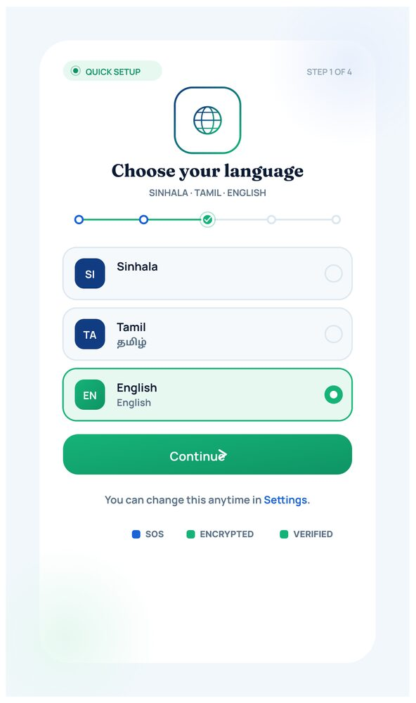

Figure 1: Language Selection Screen
The first screen presented to a new user during onboarding (Step 1 of 4) allows the selection of the interface language, with Sinhala, Tamil, and English currently supported. Presenting language choice as the very first step ensures the safety and legal-aid content that follows is accessible to users across Sri Lanka's main language groups. Trust indicators for SOS availability, encryption, and identity verification are shown at the bottom of every onboarding screen to reassure the user early in the flow.
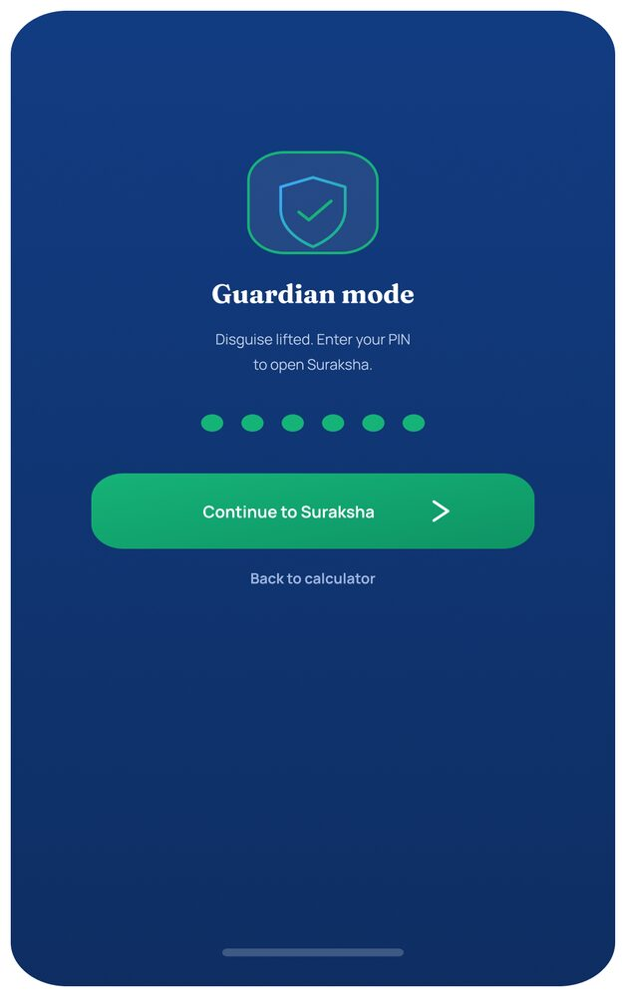
Figure 2: Guardian Mode Activation (PIN Entry)
This screen demonstrates the application's core safety mechanism: by default, the app is disguised as an ordinary calculator, and entering a private PIN switches it into "Guardian mode," unlocking the real Suraksha application. A segmented PIN indicator and a clear "Continue to Suraksha" action are provided, along with a fallback link to return to the calculator view, so the disguise can be re-engaged instantly if someone else picks up the device.
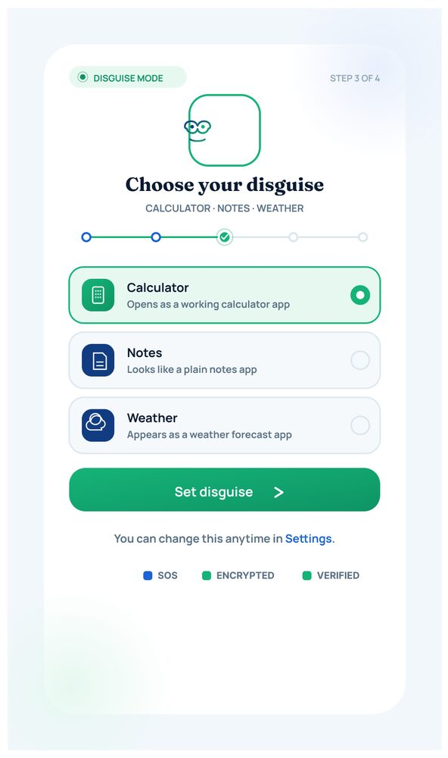
Figure 3: Choose Your Disguise Screen
As Step 3 of onboarding, the user selects which everyday application Suraksha should imitate on the home screen and app icon — the options implemented are Calculator, Notes, and Weather. This feature is central to the survivor-safety model of the application, allowing the tool to remain hidden from an abuser who inspects the victim's phone, while remaining one PIN entry away from full functionality.
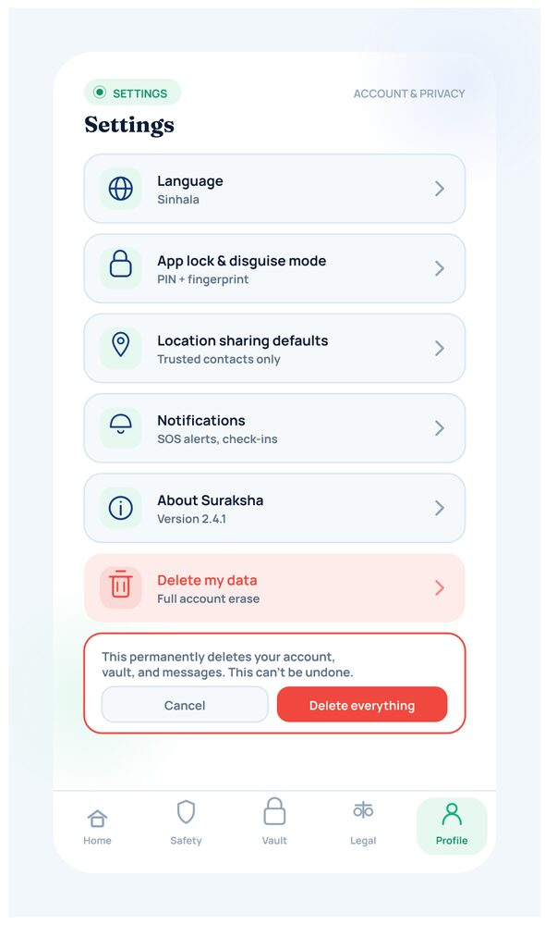
Figure 4: Settings — Account and Privacy
The Settings screen consolidates all safety-critical configuration in one place: interface language, the app-lock/disguise mode (PIN and fingerprint), default location-sharing behaviour, notification preferences, and information about the current app version. A clearly separated, high-friction "Delete my data" action (with a confirmation dialog) is also provided, giving the user full control to permanently erase their account, vault contents, and messages at any time.

5.2.2 Home Dashboard and Safety Response
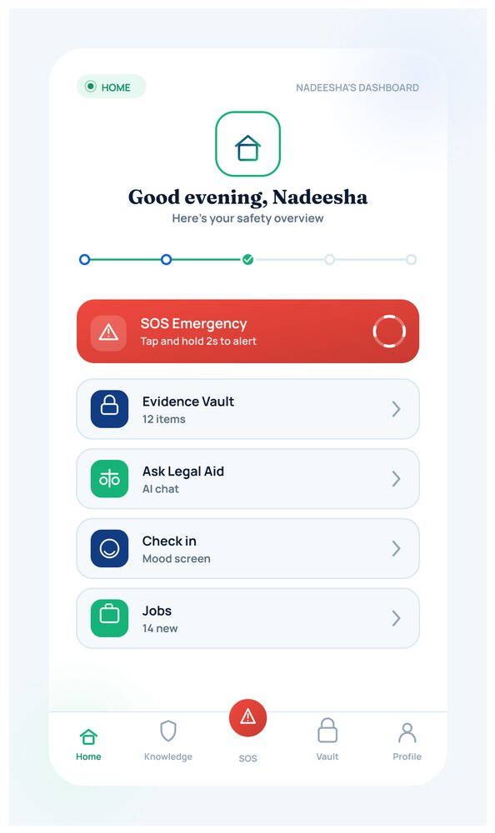
Figure 5: Home Dashboard
Once unlocked, the user lands on a personalised home dashboard ("Good evening, Nadeesha") that summarises the account's safety status at a glance. Quick-access tiles are provided for the SOS Emergency trigger, the Evidence Vault (showing item count), the AI-powered Ask Legal Aid chat, a mental-health Check-in, and Jobs/opportunities, with a bottom navigation bar giving persistent access to Home, Safety, Vault, Legal, and Profile sections.
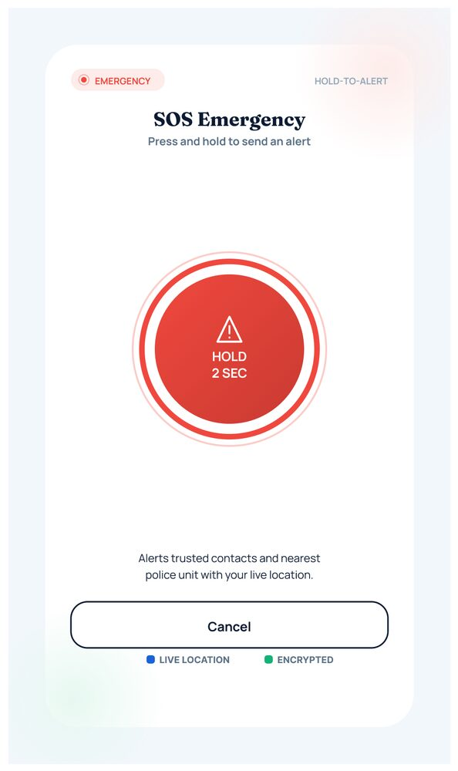
Figure 6: SOS Emergency Screen
The SOS screen implements a deliberate "hold-to-alert" pattern (hold for 2 seconds) to minimise accidental triggering while still allowing a fast, low-visibility response in a genuine emergency. Activating the button immediately alerts the user's trusted contacts and the nearest police unit and shares the user's live location, with a visible "Cancel" option retained in case the alert was triggered by mistake.
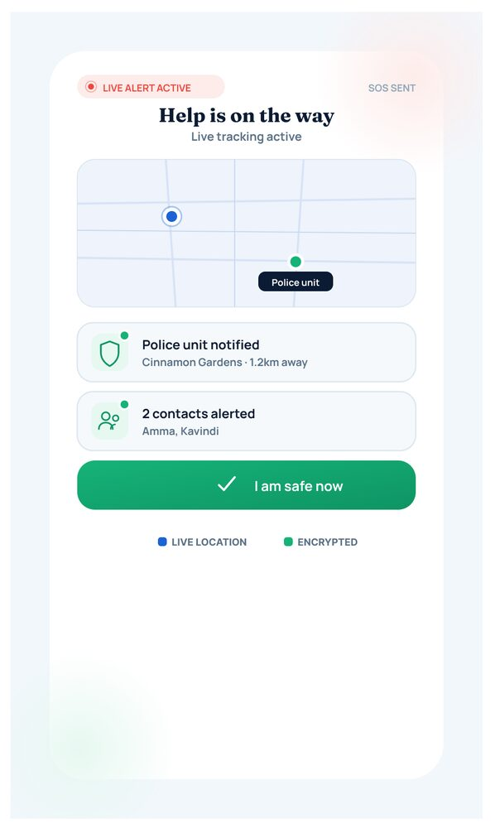
Figure 7: Help Is On The Way Screen
Following a successful SOS trigger, this confirmation screen shows live tracking status, confirms that the nearest police unit has been notified (with distance/ETA), and lists which trusted contacts have been alerted. A prominent "I am safe now" button lets the user stand the alert down once the situation has been resolved, closing the loop for the responding parties.
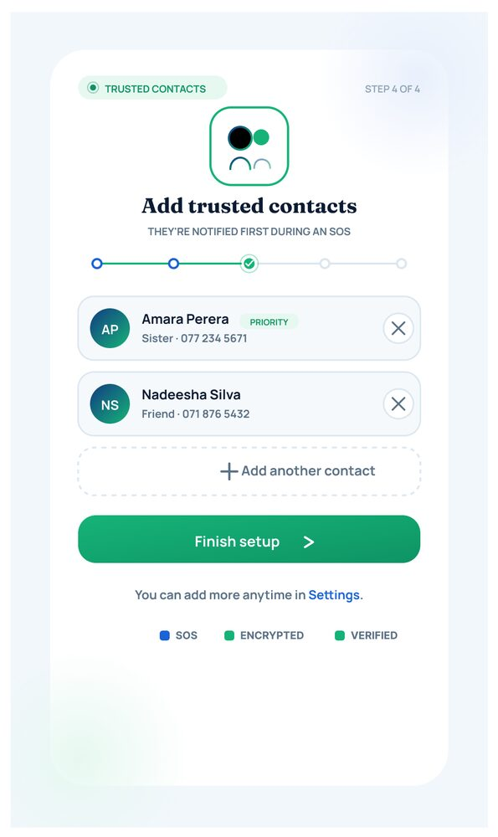
Figure 8: Add Trusted Contacts Screen
As the final onboarding step (Step 4 of 4), the user builds a list of trusted contacts who will be notified first during an SOS event, before police involvement, giving the user a softer first line of support. Each contact shows their relationship to the user and phone number, and additional contacts can be added at any time from Settings.
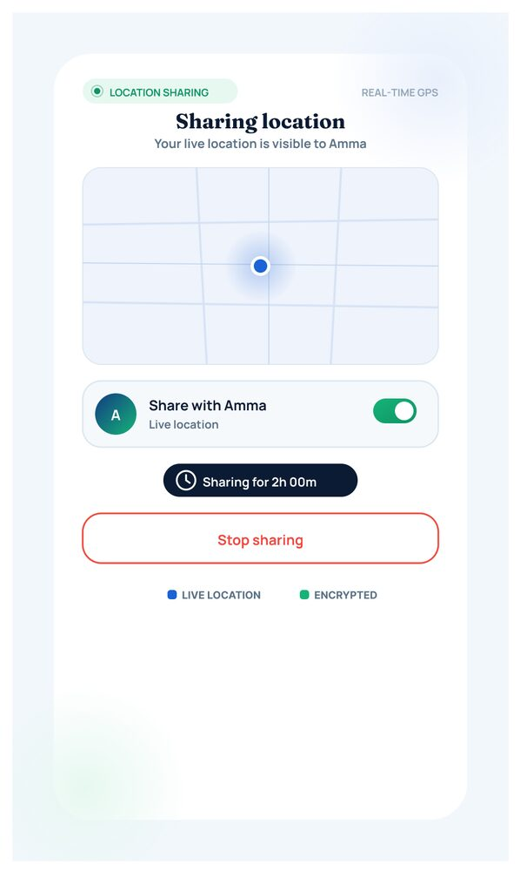
Figure 9: Live Location Sharing Screen
This screen allows the user to share their real-time location with a specific trusted contact ("Share with Amma") for a defined duration (e.g., 2 hours), visualised on a live map. A single toggle enables or disables sharing, and a "Stop sharing" action is always available, balancing safety benefits with the user's control over their own privacy.
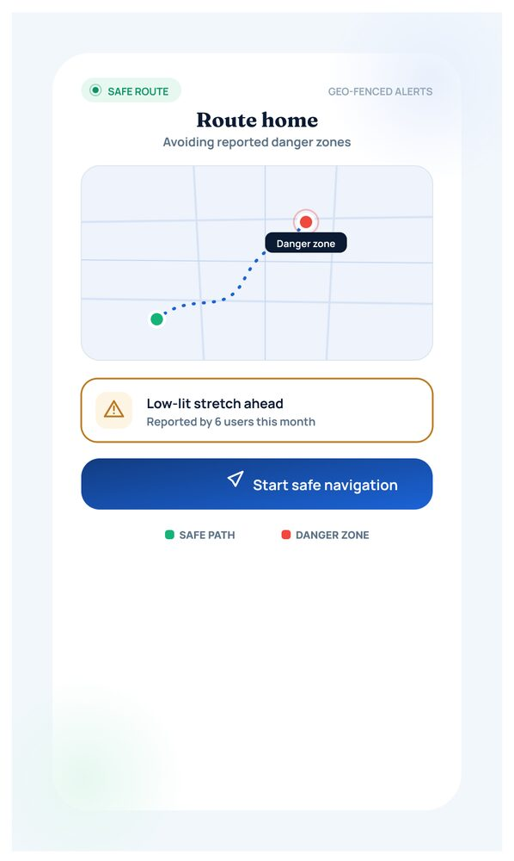
Figure 10: Route Home (Safe Navigation) Screen
The Safe Route feature calculates a walking route home while actively avoiding areas that have been reported as danger zones by other users, and flags any low-lit stretches ahead. Colour-coded route segments distinguish the safe path from danger zones, and a "Start safe navigation" action begins live, GPS-fenced guidance with automatic alerts if the user deviates into a flagged area.

5.2.3 Evidence Collection and AI-Assisted Detection
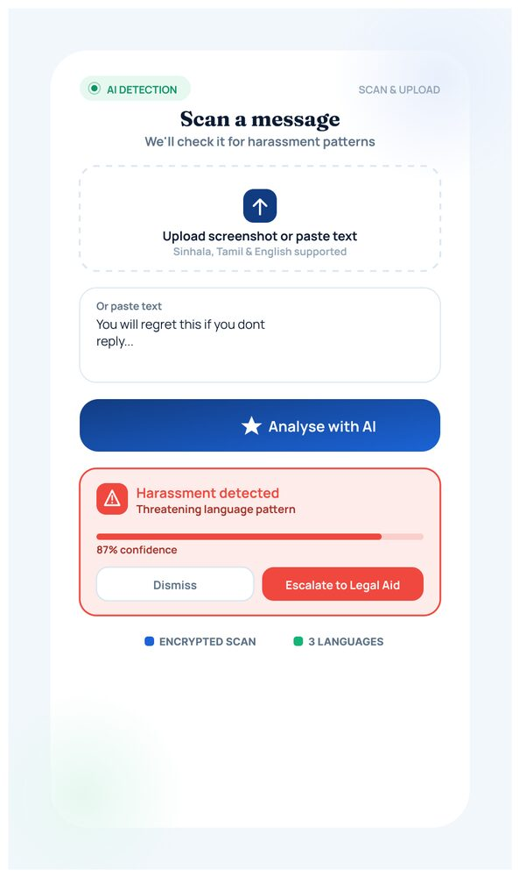
Figure 11: Scan a Message Screen
This screen lets the user upload a screenshot or paste text of a message they have received, which is then analysed by the platform's AI harassment-detection model (supporting Sinhala, Tamil, and English). In the implemented example, the model flags "Harassment detected — threatening language pattern" with an 87% confidence score, and offers the user the option to Dismiss the flag or Escalate to Legal Aid directly from the result.
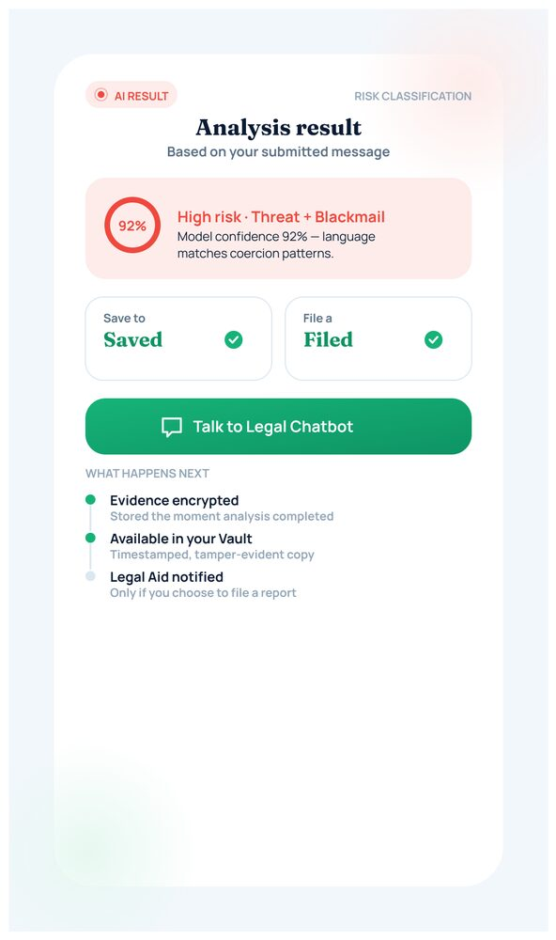
Figure 12: AI Analysis Result Screen
Following a scan, this screen presents the full AI risk classification for the submitted message, in this case a High-risk / Threat + Blackmail classification at 92% model confidence. The result is saved automatically to the user's encrypted evidence vault, and direct actions are provided to file a legal-aid report or continue the conversation with the Legal Aid chatbot, along with a short explanation of what happens next and how the evidence is protected.
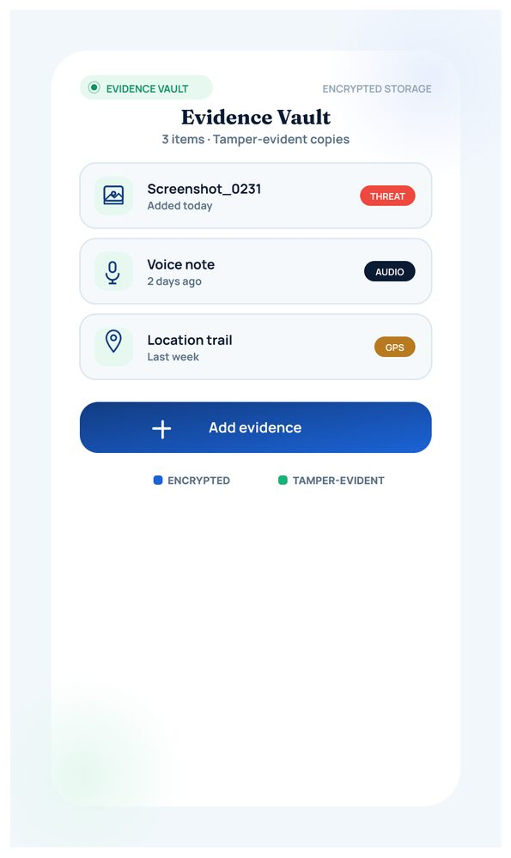
Figure 13: Evidence Vault Screen
The Evidence Vault provides tamper-evident, encrypted storage for all evidence the user has collected, including screenshots, voice notes, and location trails, each timestamped and labelled with its type. A single "Add evidence" action lets the user grow this collection at any time, and the vault contents can later be attached directly to a formal report.
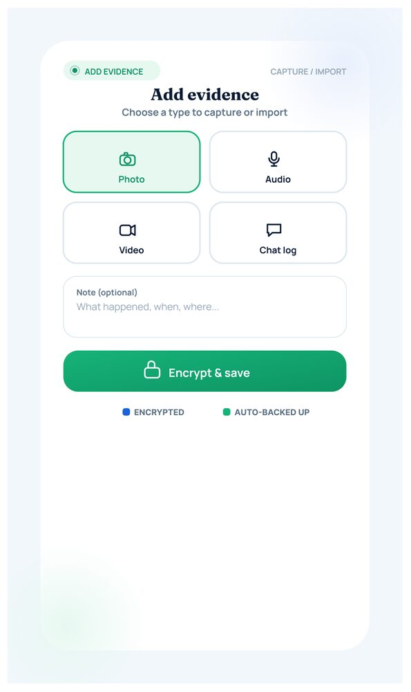
Figure 14: Add Evidence Screen
This screen allows the user to capture or import new evidence in four formats — Photo, Audio, Video, or Chat log — together with an optional note describing what happened, when, and where. Once submitted, items are immediately "Encrypted & saved" to the vault, reinforcing the chain-of-custody requirements needed if the evidence is later used in a legal or police process.
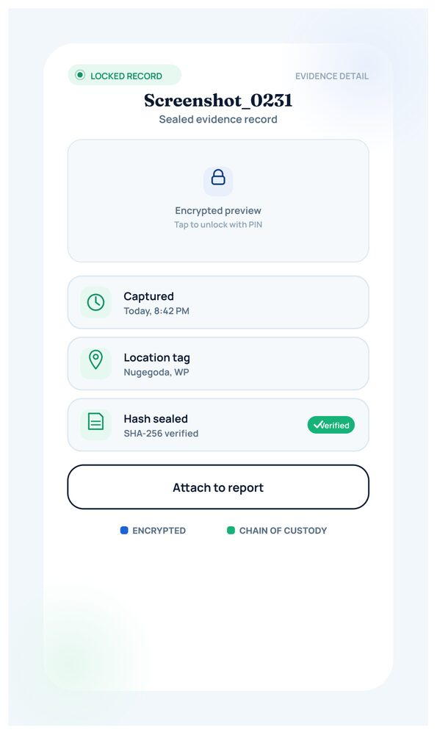
Figure 15: Evidence Detail — Sealed Record Screen
Once an item (e.g., Screenshot_0231) has been attached to a report, it becomes a locked, sealed evidence record: the raw content is hidden behind an encrypted preview that can only be unlocked with the user's PIN, while its capture time, location tag, and SHA-256 integrity hash remain visible and verified. This design preserves evidentiary integrity while still allowing the user to attach the sealed item to an active report.

5.2.4 Reporting and Legal Aid
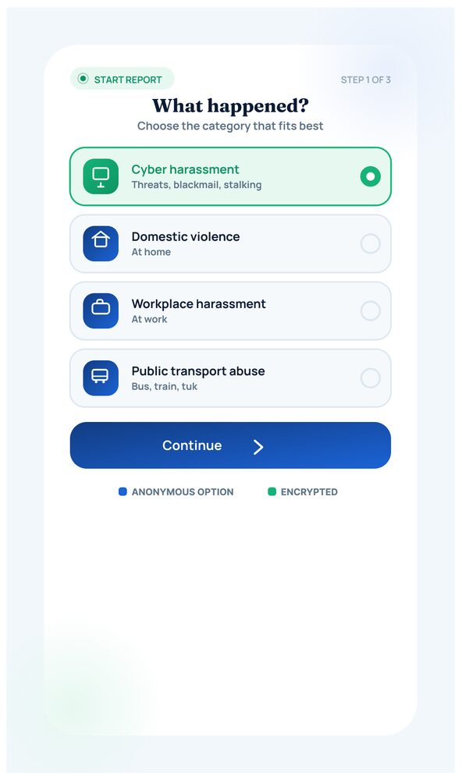
Figure 16: Start a Report — Category Selection Screen
This is Step 1 of the reporting workflow, where the user selects the category that best matches their situation from options such as Cyber Harassment, Domestic Violence, Workplace Harassment, and Public Transport Abuse. Categorising the incident at the outset allows the system to route the report to the correct downstream workflow and to pre-fill relevant legal guidance later in the process.
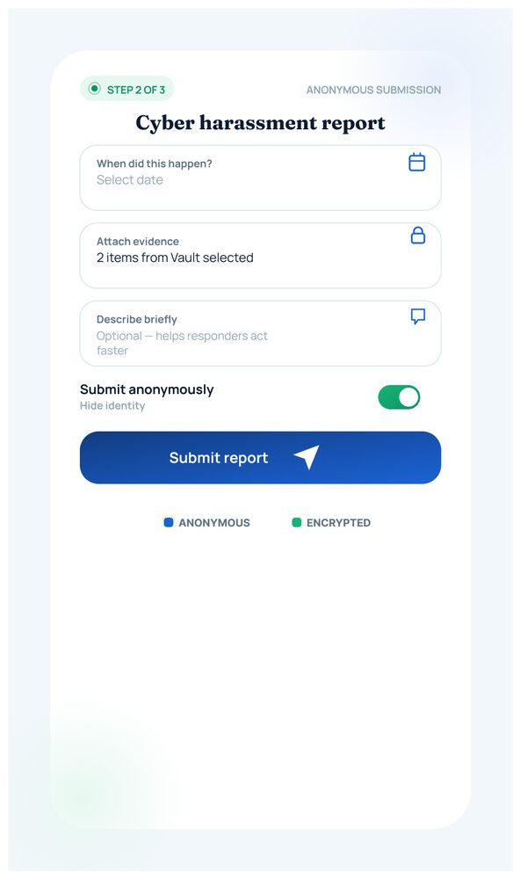
Figure 17: Cyber Harassment Report Form
As Step 2 of 3, the report form collects structured details of the incident — when it happened, supporting evidence pulled directly from the Evidence Vault, and a free-text description — while an "Submit anonymously" toggle lets the user choose whether to hide their identity from anyone but the assigned case handler. This balances the need for actionable detail with the user's right to control their own exposure.
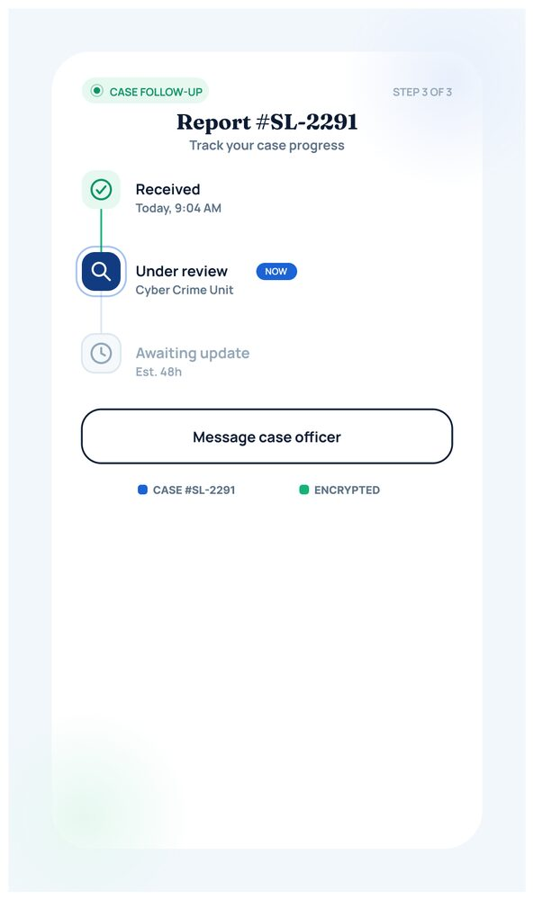
Figure 18: Report Tracking Screen (#SL-2291)
Once submitted, the user can follow their case's progress through a simple status tracker — Received, Under review, and further stages — matching the same case reference number used across the Admin and Police dashboards. A "Message case officer" action keeps a direct communication channel open, and the screen reiterates that the case is encrypted and tied to the same #SL-2291 identifier used across the whole platform.
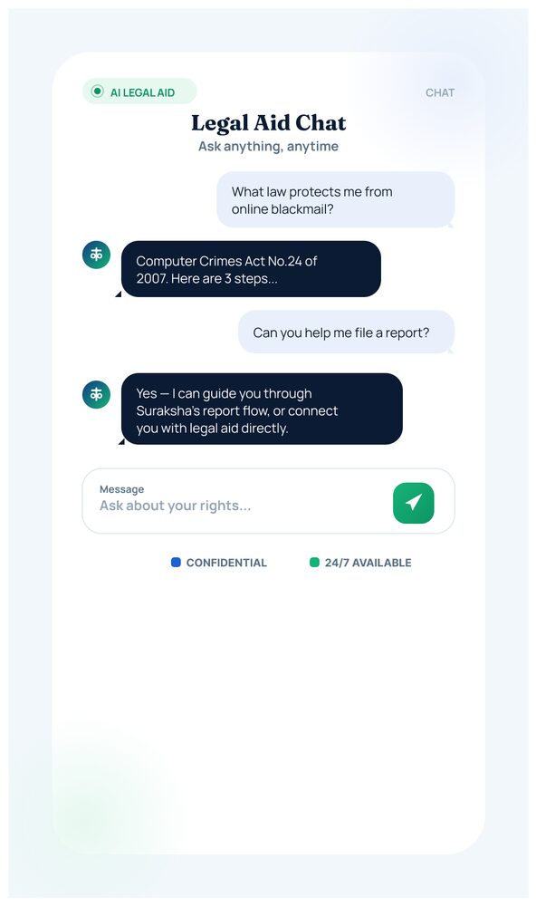
Figure 19: Legal Aid Chat Screen
The AI Legal Aid Chat gives the user instant, conversational access to plain-language legal information (for example, an explanation of the Computer Crimes Act No. 24 of 2007) and can guide the user step-by-step through filing a formal report or connecting them directly with a human legal advisor. The chat is marked confidential and available 24/7, reducing the barrier to seeking legal guidance immediately after an incident.
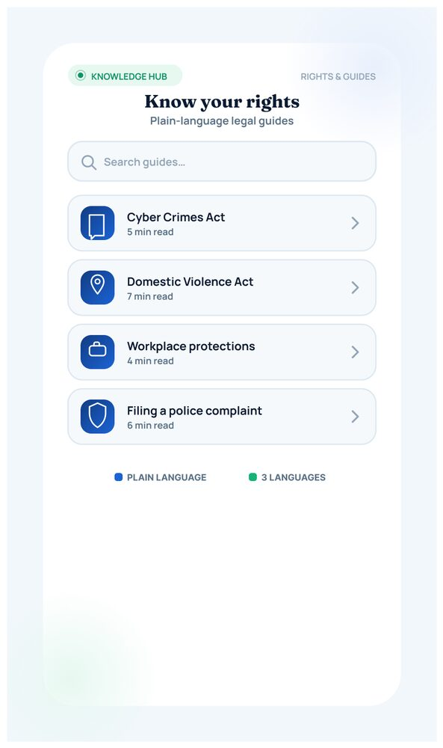
Figure 20: Know Your Rights (Knowledge Hub) Screen
This screen provides a searchable library of plain-language legal guides covering topics such as the Cyber Crimes Act, the Domestic Violence Act, workplace protections, and how to file a police complaint. Each guide displays an estimated reading time and is available in multiple languages, supporting informed decision-making independent of the AI chat.

5.2.5 Community and Wellbeing
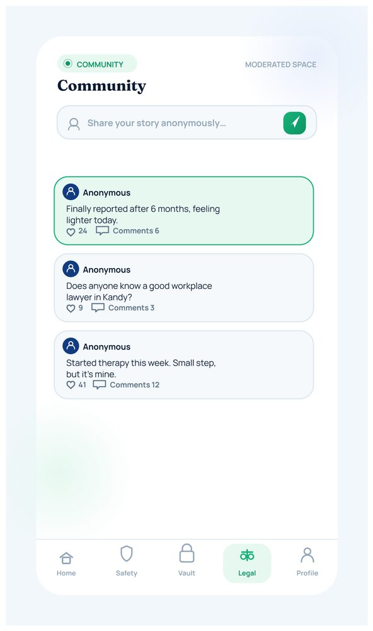
Figure 21: Community Screen
The Community screen is a moderated space where users can anonymously share their experiences and receive peer support, with each post showing relative time and comment count. All posts pass through the AI content-moderation pipeline (see Section 5.6.5) before being visible to other users, ensuring the space remains safe and constructive.
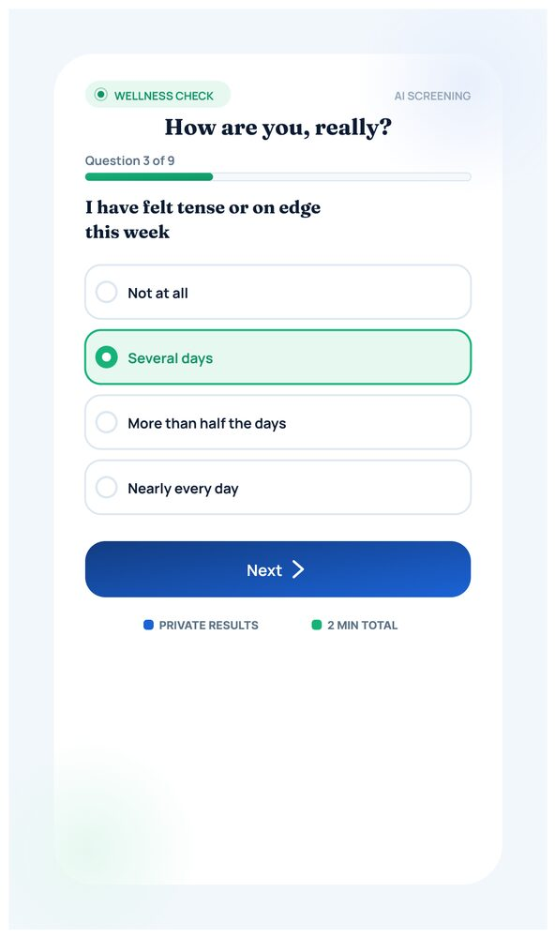
Figure 22: Wellness Check-In Screen
Implemented as a short, GAD-7-style screening questionnaire ("How are you, really?"), this screen periodically checks in on the user's emotional wellbeing through simple, non-clinical questions such as feeling tense or on edge. A progress indicator (Question 3 of 9) and reassurance text ("This is not a diagnosis") keep the tone supportive rather than clinical.
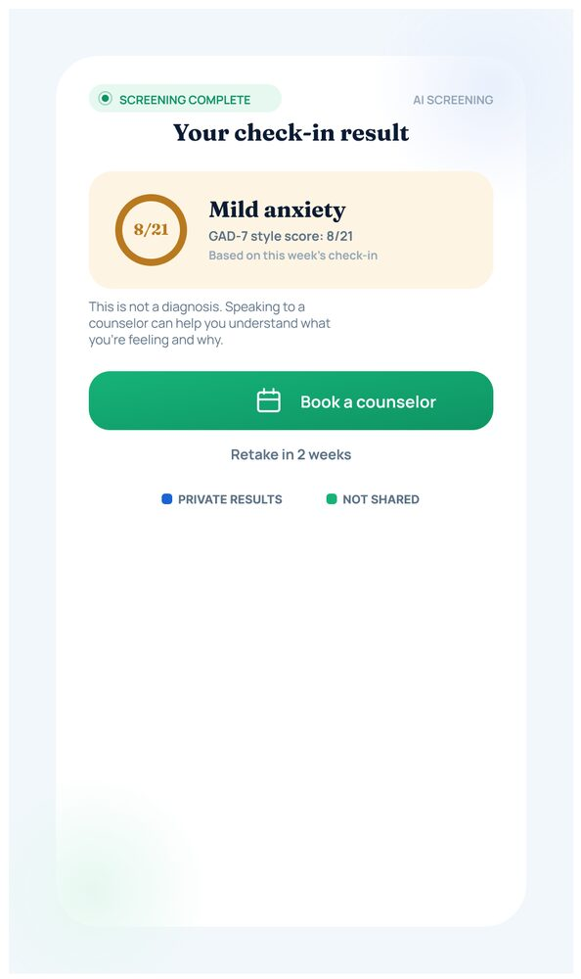
Figure 23: Check-In Result Screen
On completion, the check-in produces a plain-language result — in this example, "Mild anxiety" with a score of 8/21 — along with a note that results are private and not shared without consent. A direct "Book a counselor" call-to-action bridges the wellbeing check straight into professional support if the user chooses to proceed.
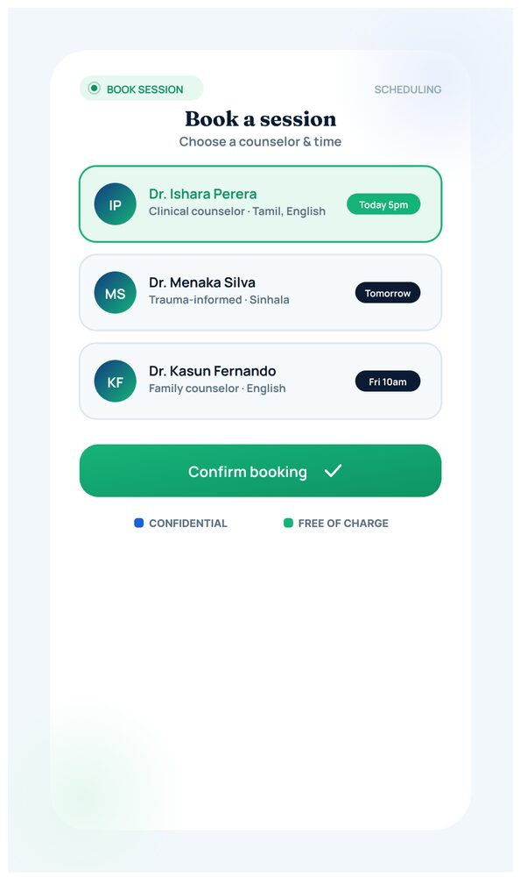
Figure 24: Book a Counselling Session Screen
This screen lets the user choose from a list of available counselors, each showing their specialisation, language, and next available slot, and confirm a booking with a single tap. The session is explicitly marked as confidential and free of charge, removing two common barriers — cost and privacy concerns — to seeking professional help.

5.3 Police Interface
The Police dashboard gives on-duty officers a real-time operational view of SOS alerts and assigned cases within their jurisdiction. It is optimised for rapid triage and status reporting rather than the broader platform-management functions available to Administrators.
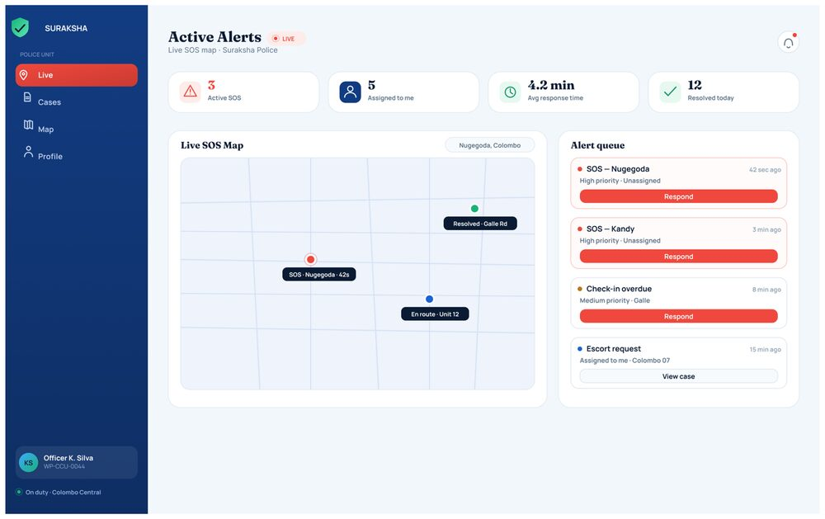
Figure 25: Active Alerts — Live SOS Map
This is the officer's landing screen, showing a live map of active SOS signals, summary counters (active SOS, alerts assigned to the officer, average response time, and cases resolved today), and a prioritised Alert Queue. Each alert card shows its type, location, and elapsed time, with a one-tap "Respond" action, allowing an officer to move from awareness to action within seconds of an alert being raised.
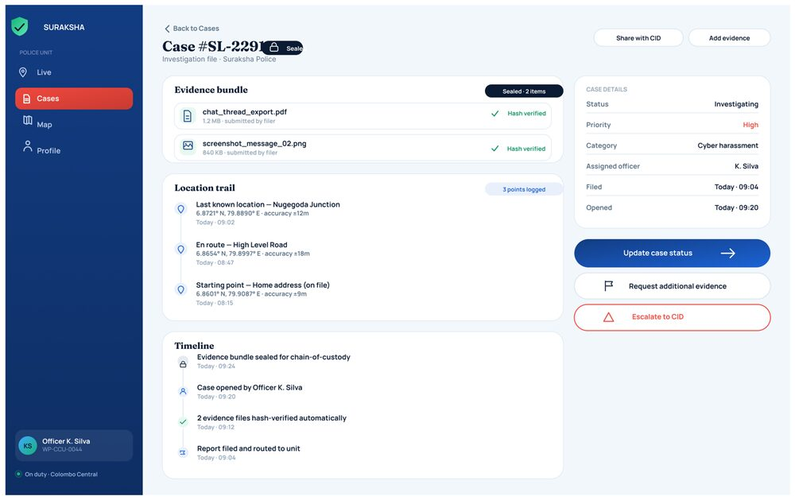
Figure 26: Case Investigation File (#SL-2291)
Opening a case from the queue presents the full investigation file: a sealed, hash-verified evidence bundle carried over from the user's report, a location trail reconstructed from the user's last known GPS points, and a chronological timeline of every action taken on the case so far. Primary actions — Update case status, Request additional evidence, and Escalate to CID — are grouped clearly alongside the case metadata (status, priority, category, and assigned officer), giving the officer everything needed to act without leaving the screen.
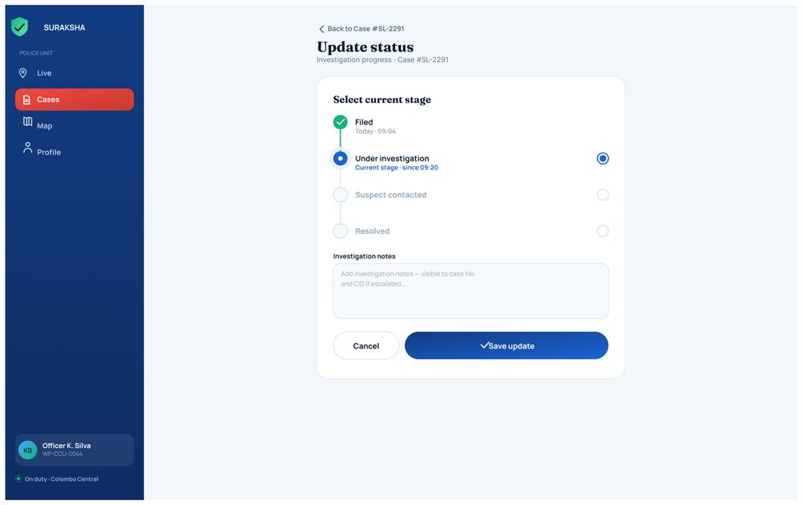
Figure 27: Update Case Status Screen
This screen implements a simple, auditable stepper for progressing an investigation through its lifecycle — Filed, Under investigation, Suspect contacted, and Resolved — with a free-text field for investigation notes that are recorded against the case file and made visible to CID if the case is later escalated. Structuring status changes this way keeps the case history in the Admin, Police, and User views consistently synchronised.

5.4 Counselor Interface
The Counselor dashboard supports the clinical and pastoral-care side of the platform, allowing licensed counselors to manage their caseload, review client wellbeing history, and record session outcomes in a structured, auditable way.
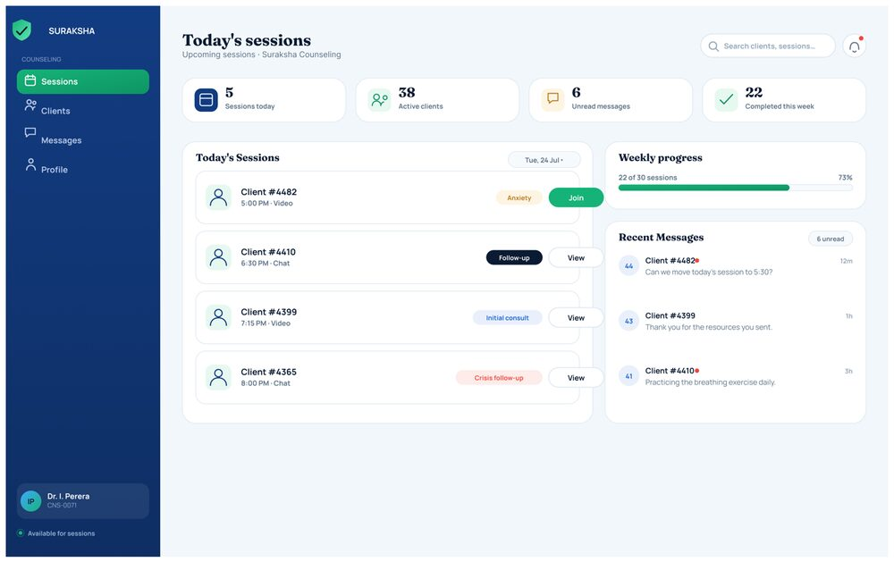
Figure 28: Today's Sessions Dashboard
The counselor's home screen summarises the day's workload — sessions scheduled today, active clients, unread messages, and sessions completed this week — alongside a chronological list of Today's Sessions, each tagged with the client's presenting concern (e.g., Anxiety, Crisis follow-up) and a one-tap Join or View action. A Recent Messages panel and weekly-progress bar are shown alongside, keeping communication and caseload targets visible without needing to navigate away.
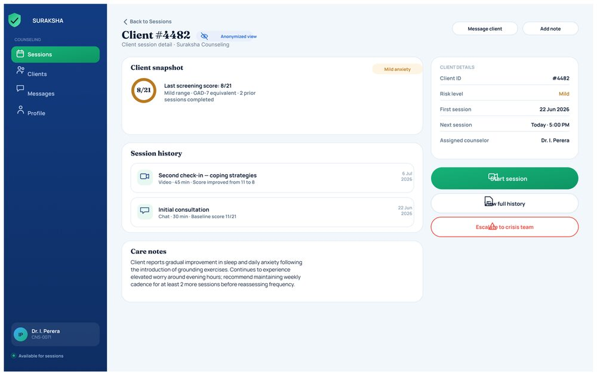
Figure 29: Client Snapshot (#4482)
Selecting a client opens an anonymised client-session detail view combining a wellbeing snapshot (most recent screening score, risk level, and number of prior sessions), a full session history with duration and modality (chat/video), and free-text care notes documenting clinical observations and recommended cadence. Quick actions — Start session, View full history, and Escalate to crisis team — are placed prominently for time-sensitive decisions, while the client's identity remains anonymised in line with confidentiality requirements.
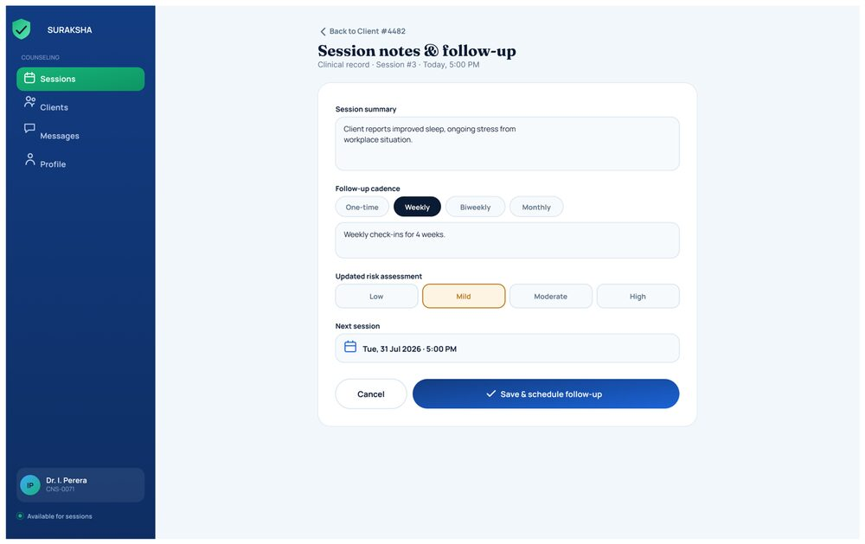
Figure 30: Session Notes and Follow-Up Screen
After a session, the counselor records a structured clinical note: a session summary, the recommended follow-up cadence (one-time, weekly, biweekly, or monthly), an updated risk-assessment rating, and the next scheduled session date. Saving the form both files the clinical record and automatically schedules the client's next appointment, keeping documentation and scheduling in a single step.

5.5 Legal Advisor Interface
The Legal Advisor dashboard connects registered advisors with legal questions raised by users through the Legal Aid Chat, and lets them manage the platform's public legal-guidance resources.
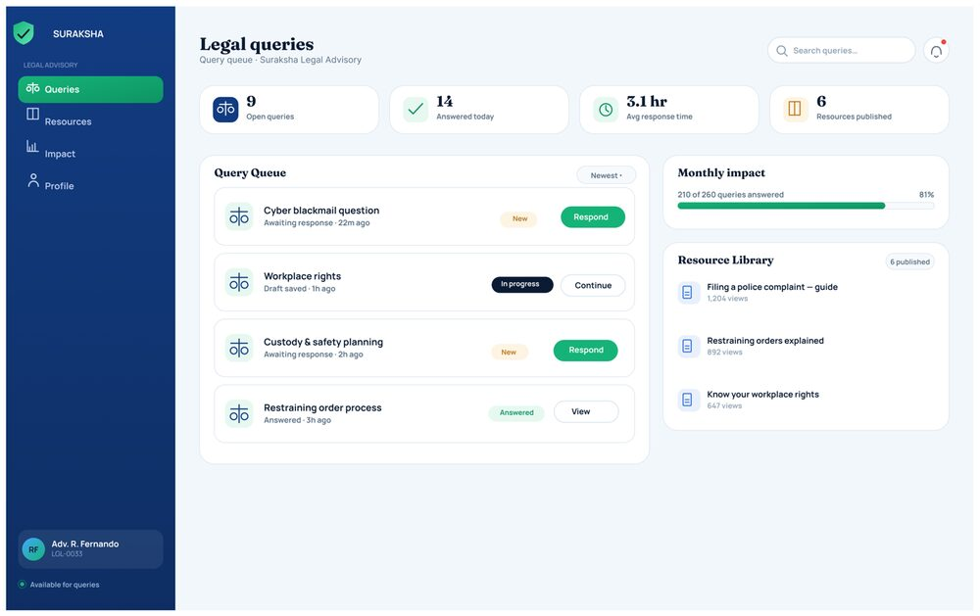
Figure 31: Legal Queries Dashboard
This is the Legal Advisor's primary workspace, summarising open queries, queries answered today, average response time, and published resources. The Query Queue lists incoming questions (e.g., "Cyber blackmail question," "Custody & safety planning") with their status — New, In progress, or Answered — and a direct Respond or Continue action, while a side panel tracks monthly response-rate impact and provides quick access to the Resource Library used to populate the User-side Know Your Rights section. The left-hand navigation (Queries, Resources, Impact, Profile) indicates the advisor's full scope of responsibility within the platform, of which the query queue is the primary day-to-day view.

5.6 Admin Interface
The Admin dashboard gives platform operations staff full oversight of the system: incoming reports, registered users, community content, and the health of the underlying AI models. It is the only interface with visibility across every case and every role, and is responsible for triage, escalation, and quality control across the whole platform.

5.6.1 Platform Overview
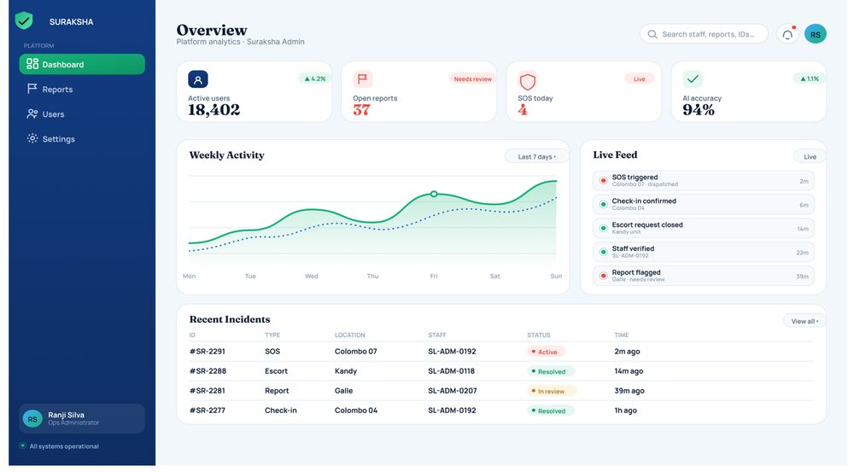
Figure 32: Admin Dashboard — Overview
The Overview screen is the administrator's landing page, presenting platform-wide key metrics — total active users, open reports, SOS events today, and staff-verification rate — alongside a weekly activity trend chart. A Live Feed streams recent platform events (SOS triggers, check-in confirmations, escort requests) in real time, and a Recent Incidents table lists the newest cases with their type, location, assigned officer, and status, giving the administrator a single-glance summary of platform health.

5.6.2 User Management
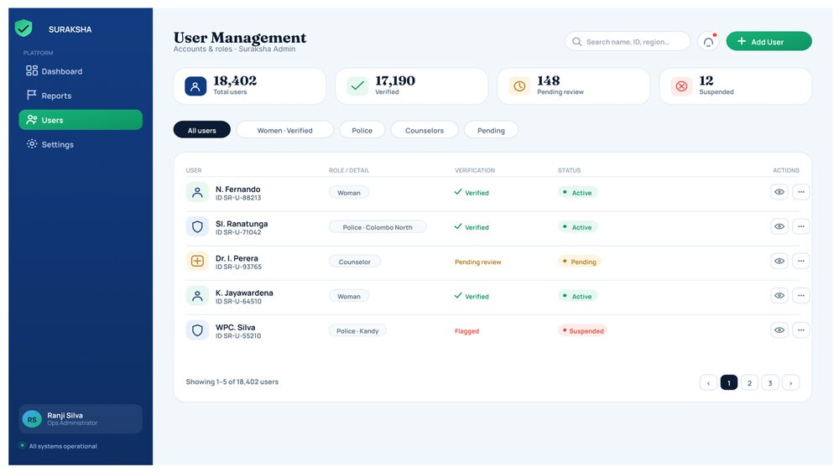
Figure 33: User Management Screen
This screen lists every registered account on the platform with counters for total, verified, pending, and suspended users, and filter tabs to view All users, Women, Verified, Police, Counselors, or Pending accounts. Each row shows the user's role/detail, verification status, and account status, with quick actions to view or edit records — supporting the administrator's responsibility for verifying professional accounts (Police, Counselors) and moderating suspicious or suspended users.

5.6.3 Reports Queue and Case Escalation
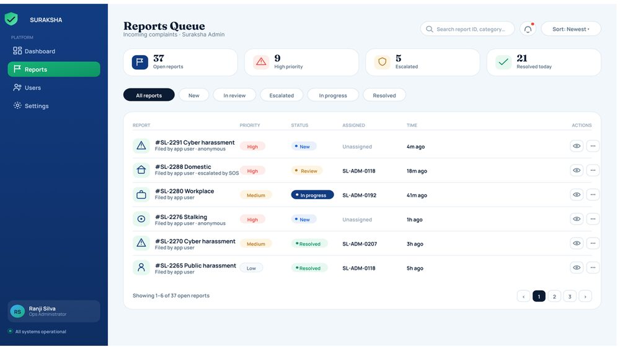
Figure 34: Reports Queue Screen
The Reports Queue is the administrator's central triage tool, listing every incoming complaint with its reference number, category, priority, status, assigned handler, and time filed, filterable by New, In review, Escalated, In progress, and Resolved. Colour-coded priority tags (e.g., High priority in red) allow the administrator to quickly identify which of the platform's open reports require the most urgent attention.
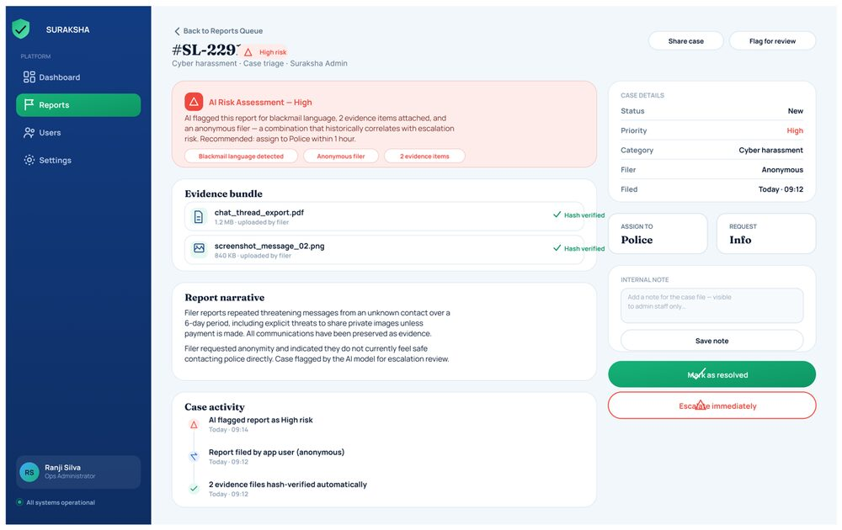
Figure 35: Case Detail and Escalation Screen (#SL-2291)
Opening a report from the queue surfaces the full case package: an AI Risk Assessment banner summarising why the model flagged the case as high risk (blackmail language detected, anonymous filer, multiple evidence items) together with a recommended action, the attached evidence bundle with automatic hash verification, the filer's report narrative, and a full case-activity audit trail. From here the administrator can assign the case directly to Police, request more information from the filer, leave an internal note, mark the case resolved, or escalate it immediately — this is the same case (#SL-2291) later shown from the Police officer's perspective in Section 5.3, illustrating how a single incident flows across roles.

5.6.4 Content Moderation
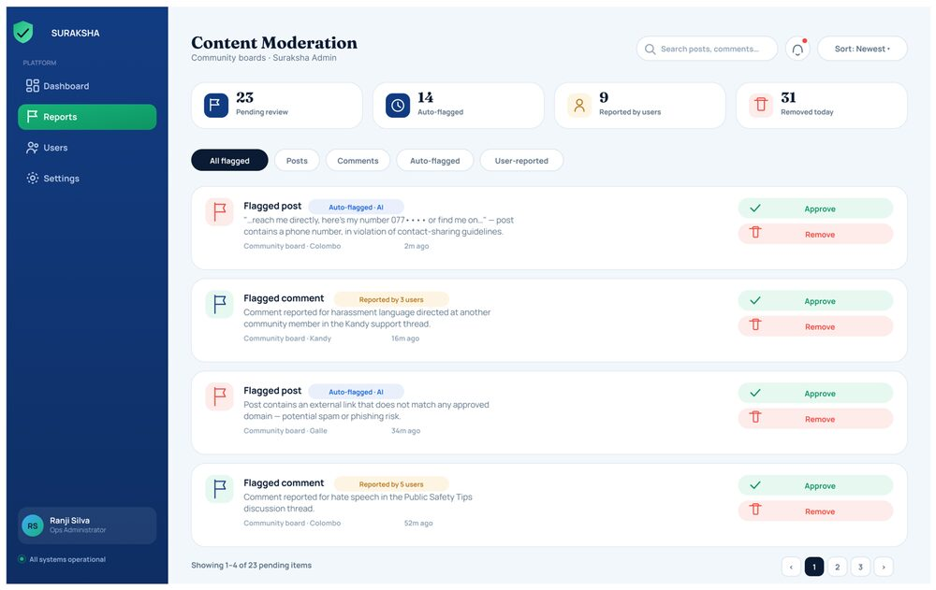
Figure 36: Content Moderation Screen
This screen queues community posts and comments that have been auto-flagged by the AI model or reported by users — for example, a post sharing a phone number in violation of contact-sharing guidelines, or a comment reported for harassment — and lets moderators Approve or Remove each item individually. Summary counters (pending review, auto-flagged, reported by users, removed today) give the administrator visibility into moderation workload and the balance between automated and community-driven flagging.

5.6.5 AI Model Monitoring
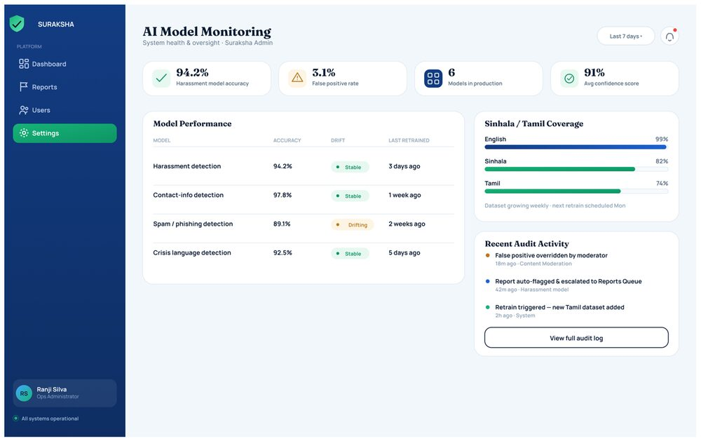
Figure 37: AI Model Monitoring Screen
Found under Settings, this screen gives the administrator oversight of every AI model running in production — harassment detection, contact-info detection, spam/phishing detection, and crisis-language detection — showing each model's current accuracy, drift status, and last retraining date. A Sinhala/Tamil Coverage panel tracks how well each supported language is served by the models (English 99%, Sinhala 82%, Tamil 74%), and a Recent Audit Activity feed logs moderator overrides and automatic escalations, supporting transparent, accountable oversight of the AI components used throughout the platform.

5.7 Discussion
The preceding sections presented the implemented screens for each of the five Suraksha roles. This section interprets those results against the study’s objectives, research questions, and the research gap identified in Chapter 2, and considers what the current level of implementation does and does not yet demonstrate. In Design Science Research terms (Peffers et al.), Sections 5.2–5.6 correspond to the Demonstration stage of the DSRM cycle described in Section 4.2: they show that the artefact can be instantiated and used in realistic scenarios. The formal Evaluation stage — System Usability Scale scoring, precision/recall testing of the AI models, and the pre-/post-test surveys described in Section 4.6 — falls outside the scope of this chapter and is treated as the next stage of the research cycle; the discussion below is therefore framed around design intent and demonstrated capability rather than measured outcomes.

5.7.1 Addressing the Study Objectives
Most of the secondary objectives set out in Section 1.3 are directly traceable to specific screens. Harassment, threat, and blackmail detection is realised through the Scan a Message and AI Analysis Result screens (Figures 11–12), with model oversight surfaced separately to administrators through the AI Model Monitoring screen (Figure 37). The objective of a secure, encrypted evidence repository is met by the Evidence Vault, Add Evidence, and Sealed Record screens (Figures 13–15), which implement encryption-at-rest, timestamping, and SHA-256 integrity hashing as a chain-of-custody mechanism. Emergency and location-based safety objectives are addressed through the hold-to-alert SOS flow, live tracking confirmation, trusted-contact management, live location sharing, and danger-zone-aware safe routing (Figures 6–10), which are mirrored on the Police side through the live SOS map and case investigation file (Figures 25–26).
The objective of anonymous reporting is fulfilled by the category-selection and report-form screens, including the explicit “Submit anonymously” toggle (Figures 16–18), while the objective of an AI-powered legal assistant is met by the Legal Aid Chat and its connection to the Legal Advisor’s Query Queue (Figures 19 and 31). Mental-health objectives are addressed through the GAD-7-style check-in, its result screen, and direct booking into the Counselor dashboard (Figures 22–24, 28–30), and the objective of a moderated survivor community is met by the Community screen and its dependency on the content-moderation pipeline (Figures 21 and 36). The knowledge-hub objective is met by the Know Your Rights screen (Figure 20), and the privacy-by-design objectives — disguise mode, PIN/biometric lock, and Sinhala/Tamil/English language support — are addressed from the very first onboarding steps (Figures 1–4).
One objective is only partially realised at this stage: the economic-empowerment component. The current prototype surfaces a single “Jobs” quick-access tile on the Home Dashboard (Figure 5), but no dedicated job-listing, application, or skills-development screens were implemented in this iteration. This represents the clearest gap between the objectives stated in Section 1.3 and the artefact demonstrated in this chapter, and is carried forward as a priority for the next development iteration rather than treated as resolved. The final objective — assessing effectiveness, usability, security, and acceptance — is, by design, not addressed by this chapter at all, since it corresponds to the Evaluation stage of the DSRM cycle rather than the Demonstration stage reported here.

5.7.2 Discussion of the Research Questions
Of the ten research questions listed in Section 3.2, this chapter speaks most directly to those concerned with what the system does rather than what effect it has on users, since the latter requires the pilot evaluation described in Section 4.6 rather than screen-level results. RQ4 (“How well can AI methods identify cyberbullying and offensive online content?”) is demonstrated functionally by the classification workflow in Figures 11–12, where a submitted message is returned with a risk category and a confidence score; RQ2, which asks specifically about Sinhala- and Tamil-language effectiveness, is only partly answerable from the prototype: the AI Model Monitoring screen (Figure 37) reports illustrative per-language coverage of 99% for English against 82% for Sinhala and 74% for Tamil. Read as a design target rather than a validated result, this gap is consistent with the low-resource-language limitation already anticipated in Sections 4.4 and 4.8, and indicates that Sinhala and Tamil model performance should be treated as a specific focus of the Evaluation stage rather than assumed to match English performance.
RQ3 and RQ5, which concern the effect of a hidden, encrypted evidence vault on women’s confidence and reporting behaviour, are addressed at the architectural level by the vault’s sealed-record design (Figure 15), but the behavioural effect this design has on reporting — the actual object of both questions — can only be established through the pilot pre-/post-test surveys proposed in Section 4.6. Similarly, RQ6 (anonymous legal advice and legal awareness), RQ7 (geo-fenced routing and perceived safety), and RQ8 (mental-health tools and help-seeking intentions) each have a corresponding mechanism in the prototype — the Legal Aid Chat and Know Your Rights hub, the Safe Route screen, and the check-in-to-booking flow, respectively — but in each case the research question asks about an effect on the user, which this results chapter is not positioned to answer. RQ9 (usability, trust, and satisfaction) and RQ1 (demographic variation in the challenges women face) remain entirely reserved for the needs-assessment and evaluation phases of the methodology. RQ10, on the employment portal’s contribution to economic empowerment, cannot yet be discussed beyond intent, given the limited implementation noted in Section 5.7.1.

5.7.3 Relating the Results to the Literature Review
Section 2.2 identified three specific gaps in existing work: single-purpose tools that isolate one aspect of women’s safety, harassment-detection research that is largely English-language and Western-context, and Sri Lankan applications (2six4, Cyber Care, Fio) that are issue-driven rather than integrated. The results in this chapter respond to each in turn. Where bSafe, Noonlight, and Safetipin (Section 2.1) provide reactive, physical-safety-only functions, Suraksha layers AI harassment detection, an encrypted evidence vault, legal guidance, and mental-health support onto the same SOS and location-sharing mechanisms, moving the artefact from a single-purpose alert tool toward the multi-domain support system called for in Section 2.2. Where Dinakar et al. (2011) and the ReThink app operate on English text only, the harassment-detection workflow shown in Figures 11 and 37 is explicitly designed around Sinhala, Tamil, and English, directly targeting the localisation gap — albeit, as discussed above, with Sinhala and Tamil coverage that the monitoring dashboard itself shows trailing English.
Where Woebot and 7 Cups (Section 2.1) function as standalone mental-health tools with no linkage to reporting or evidence systems, the check-in and booking flow in Figures 22–24 connects directly into the Counselor dashboard (Figures 28–30), closing the loop between screening and professional care that the literature review found missing. Most significantly, where 2six4, Cyber Care, and Fio each address a single issue in isolation, the five-role architecture demonstrated across Sections 5.2–5.6 — User, Police, Counselor, Legal Advisor, and Admin — shares one case-reference scheme (illustrated by Case #SL-2291, traceable from the user’s report tracker in Figure 18 through the Police case file in Figure 26 to the Admin escalation screen in Figure 35) across every role. This shared case identity across otherwise separate dashboards is the concrete mechanism by which this work moves beyond the “patchwork” of existing Sri Lankan tools identified in Section 2.2, toward the single, integrated platform the research set out to build.

5.7.4 Ethical Considerations Reflected in the Design
The ethical commitments described in Section 4.7 — informed consent, data minimisation, and anonymisation — are visible as concrete design decisions rather than policy statements alone. The disguise-mode and PIN-lock onboarding flow (Figures 2–3) and the high-friction “Delete my data” action in Settings (Figure 4) give the user continuous, revocable control over their own exposure, which is a practical expression of informed consent for a survivor population that may need to withdraw at any time. The counselor-side client view (Figure 29) keeps clinical detail available for care decisions while keeping client identity anonymised, and the sealed evidence record (Figure 15) protects raw evidentiary content behind a PIN even after it has been submitted to a report. Taken together, these design choices suggest that the ethical requirements of the study were treated as constraints on the system architecture itself, not only as procedural safeguards applied around data collection.

5.7.5 Chapter Summary
This chapter has presented thirty-seven implemented screens across five role-specific interfaces and discussed them against the study’s objectives, research questions, and literature-derived research gap. The results show that the great majority of the platform’s intended safety, evidentiary, legal, mental-health, and community functions have been realised in a working prototype, and that the shared case-reference architecture achieves the cross-domain integration that existing literature and existing Sri Lankan applications were found to lack. Two limitations are already visible at the demonstration stage rather than only anticipated in Section 4.8: the AI Model Monitoring screen’s own reported coverage figures indicate that Sinhala and Tamil harassment detection currently trail English performance, and the economic-empowerment objective remains only nominally represented by a single dashboard tile rather than a developed feature set. Neither limitation invalidates the design; both instead define concrete priorities — targeted Sinhala/Tamil data collection and a fuller employment/skills module — for the next iteration of development, ahead of the formal usability and model-performance evalu
4.4 Discussion
The interfaces described in Section 4.3 are implementations of the design objectives formulated in Chapter 1, and are responses to the research gap described in Chapter 2. This section will interpret these interfaces in terms of the study research questions, place them in the context of prior literature, and explain what the findings do and do not tell us about the platform's usability.
A. Meeting the Research Question and Objectives
The main research question was the lack, in Sri Lanka, of a single, integrated platform offering women safety, legal, mental health, and economic assistance services through a secured digital interface. The eleven interfaces presented in Section 4.3 show this integration happening at the level of the interface itself rather than via multiple disparate tools. From a single home screen (Fig. 8), a user can get access to an SOS trigger, an Evidence Vault, a legal assistant powered by AI, a wellbeing check-in service, and a livelihoods listing. Thus, the primary objective of integrating protection, evidence collection, legal, counseling, and empowerment services is achieved on one platform instead of a reaction to hotlines, police, or NGOs, which were described in Section 1.1.
The division of the interfaces into roles (Admin, Police, Counselor, and Citizen consoles) is the way to achieve secondary objectives: the identification-secured reporting, the chain of custody secured evidence pipeline from citizen application (Fig. 10) to the officer console (Fig. 4), and trauma-informed counseling access (Fig. 5, Fig. 6), which are different yet complementary to the emergency response pathway. This design is consistent with the multi-feature requirements identified in survey level works on the subject of smart women-safety systems [12].

B. Comparison with Existing Solutions
Contrasting with existing Sri Lankan and regional solutions, these results favor the research gap hypothesis discussed in Section 2.2 over mere reiteration of the same claim. SafeHer [24] and SakhiAlert [25] focus on SOS alerting and community alerts, while LEGALBOT [14] and other mobile-based legal assistance approaches [15] focus on providing answers to users' legal questions – both approaches map to a specific feature cluster of the Suraksha design rather than to the platform as a whole. Similarly, the entire body of research on Sinhala and Tamil offensive language detection, including hybrid Sinhala classifiers [2], hate speech and text classification papers [8], [26], the SOLD dataset [23], Subasa [27], and Tamil-specific detection work [16], [17], along with the English classifiers [10] and ReThink approach [22], concerns itself exclusively with harassment detection rather than combining it with evidence management, reporting, and legal action. In the case of the Suraksha interface design, a classifier of this kind is supposed to act as the input for the Evidence Vault and reporting functionality, rather than as a standalone filter, which is what this study sought to integrate.
The live SOS map and alert queue functionality of the police officer console (Fig. 4) extends the mobile-enabled emergency alerting mechanism tested by Panchard et al. [19] to a dispatch/response workflow with staff assignments, priority markers, and time counters, more like an emergency management application than a notification tool only. Such a comparison should not be exaggerated, however, since the present results are mere mockups of the interface, and no functional and load testing was done.

C. Trust Signalling and Disclosure Barriers
Several interface decisions have been made with the goal of addressing the stigma and fear of retaliation that Section 1.2 found to be barriers to reporting abuse for Sri Lankan women. The explicit inclusion of 256-bit encrypted sessions in the interface for the Guardian Access Portal (Figure 1), the verified-access police console with its chain-of-custody secure messaging (Figure 3), the identifier-use counselor console (Figure 6), and the tamper-resistant, encrypted Evidence Vault (Figure 10) were all made with the goal of making confidentiality and privacy promises concrete in terms of visibility at the point of first contact rather than buried within policy documents. These design decisions are compatible with obligations under the Personal Data Protection Act [20] of Sri Lanka, the AES-256 encryption practice guidelines [13], and best practices for working with survivors of gender-based violence [30].
However, these declarative trust signals are implemented in a static prototype instead of being properties of an actual system in operation. It is one thing to display an encryption/privacy/ confidentiality claim on a login page, but it is another to have those claims hold true. The difference is critical when the consequences of a broken trust are high. An independent security evaluation and user testing to determine whether the claims are indeed recognized as such remains a prerequisite for acceptance of the disclosure-barrier argument.

D. The AI Legal Assistant and the NLP Localisation Gap
The inclusion of the "Ask Legal Aid" shortcut on the home screen (Fig. 8) is in line with trends towards the retrieval-augmentation and chatbot-powered legal self-help tools [1] and access-to-justice services via AI [18], [28]. Framing legal advice through a conversational interface reduces the perception of the effort required to ask for legal information, but it is well known from technology-acceptance literature that usability and usefulness, not just availability, play a role in adoption [7]. While the present results are only those for an entrance into this functionality, not a fully developed legal reasoning system, it remains a design concept without proven capability.
This warning must be raised even more forcefully for the harassment-detection pipeline described in Section 4.5, which involves a classical model and a fine-tuned lightweight transformer [29]. Sri Lankan NLP resources for Sinhala- and Tamil-language detection are still at the earliest stages compared to the English-language corpora used for the existing literature on harassment detection [10], [22], although the gap is slowly closing [2], [8], [16], [17], [23], [26], [27]. Nevertheless, these results have yet to yield output from a trained, localised model, and thus far mark the largest open gap in the work presented in Section 4.3.

E. Methodological Positioning and the Evaluation Gap
From the point of view of the Design Science Research framework adopted for this project [11], [21], the eleven screens correspond to the Design & Development and Demonstration stages of the DSRM framework, but not its Evaluation stage. The planned mixed-methods evaluation, including SUS scores [3], [5], pre- and post-questionnaires [6], and thematic analysis of the qualitative feedback [4] have not yet been conducted on these artefacts. The questions of usability, trust, and satisfaction formulated in the research questions of Section 4.3 therefore cannot yet be answered on the basis of the results of this section; the results prove the existence of a consistent and complete design which can then be evaluated, not a substitute for evaluation. Taking into account the scope of the problem outlined for Sri Lanka [9], the evaluation would also require a socio-demographically diverse sample for its results to be generalizable.

F. Limitations of the Current Results
There are three limitations that should be taken into account in interpreting the results above. First, the mockups shown are only in the English language, while the trilingual requirement (Sinhala, Tamil, English) formulated in Section 1.3 is not yet present in any of the screens, so the results are silent on the language accessibility. Second, the screens show only primary and successful interactions of the user with the system, which includes login, dashboard, SOS trigger, evidence storage, and booking, without considering error states, offline mode and other scenarios, such as false triggering of the SOS button, which are also important for the safety-critical application in question. Third, the current results contain no information about the performance of the system backend, accuracy of its models and its security posture; they only describe the functionality of the system.

References
[1] A. Ajmi, "Revolutionizing access to justice: The role of AI-powered chatbots and retrieval-augmented generation in legal self-help," The Brief, vol. 53, no. 2, p. 10, 2024.
[2] W. D. A. S. D. Amali and S. Jayalal, "A hybrid approach for cyberbullying detection in Sinhala social media," in Proc. Int. Conf. Advances in ICT for Emerging Regions (ICTer), 2020.
[3] A. Bangor, P. T. Kortum, and J. T. Miller, "An empirical evaluation of the System Usability Scale," Int. J. Hum.-Comput. Interact., vol. 24, no. 6, pp. 574-594, 2008.
[4] V. Braun and V. Clarke, "Using thematic analysis in psychology," Qual. Res. Psychol., vol. 3, no. 2, pp. 77-101, 2006.
[5] J. Brooke, "SUS: A 'quick and dirty' usability scale," in Usability Evaluation in Industry, P. W. Jordan, B. Thomas, B. A. Weerdmeester, and A. L. McClelland, Eds. London, U.K.: Taylor & Francis, 1996, pp. 189-194.
[6] J. W. Creswell and V. L. Plano Clark, Designing and Conducting Mixed Methods Research, 3rd ed. Thousand Oaks, CA, USA: SAGE Publications, 2018.
[7] F. D. Davis, "Perceived usefulness, perceived ease of use, and user acceptance of information technology," MIS Q., vol. 13, no. 3, pp. 319-340, 1989.
[8] N. De Silva, "Sinhala text classification: Observations from the perspective of a resource poor language," arXiv preprint, 2019.
[9] Department of Census and Statistics and United Nations Population Fund (UNFPA), Women's Wellbeing Survey 2019: Findings from Sri Lanka's First Dedicated National Survey on Violence Against Women and Girls. Colombo, Sri Lanka: Dept. of Census and Statistics, 2019.
[10] K. Dinakar, R. Reichart, and H. Lieberman, "Modeling the detection of textual cyberbullying," in Proc. Int. AAAI Conf. Web and Social Media, vol. 5, no. 2, pp. 11-17, 2011.
[11] A. R. Hevner, S. T. March, J. Park, and S. Ram, "Design science in information systems research," MIS Q., vol. 28, no. 1, pp. 75-105, 2004.
[12] International Journal of Research Publication and Reviews (IJRPR), "A survey on smart women safety systems with location tracking, geofencing alerts, and AI-based threat detection systems," IJRPR, vol. 7, no. 3, pp. 3641-3647, 2026.
[13] Kiteworks, "Everything you need to know about AES-256 encryption," Kiteworks Risk & Compliance Glossary, 2025.
[14] "LEGALBOT - AI law advisor chatbot," Int. J. Novel Res. Dev., n.d.
[15] "Mobile application-based women's safety and security system using AI," ResearchGate, 2024.
[16] "Multi-tier linguistic and emotional modeling for cyberbullying detection in Tamil social media," Expert Syst. Appl., 2025, in press.
[17] Omdena and DreamSpace, "AI for Tamil hate speech detection," n.d.
[18] Organisation for Economic Co-operation and Development (OECD), AI in Justice Administration and Access to Justice: Governing With Artificial Intelligence. Paris, France: OECD, 2025.
[19] J. Panchard, P. Papadimitratos, J.-P. Hubaux, and F. Legendre, "Mobile-enabled solutions for emergency alerting in urban environments," in Proc. ACM Workshop on Wireless Networks and Systems for Developing Regions, 2010.
[20] Parliament of Sri Lanka, Personal Data Protection Act, No. 9 of 2022, Colombo, Sri Lanka, 2022.
[21] K. Peffers, T. Tuunanen, M. A. Rothenberger, and S. Chatterjee, "A design science research methodology for information systems research," J. Manage. Inf. Syst., vol. 24, no. 3, pp. 45-77, 2007.
[22] T. Prabhu, "ReThink: A tool to combat cyberbullying using natural language processing," ReThink Inc., 2016.
[23] T. Ranasinghe, I. Anuradha, D. Premasiri, K. Silva, H. Hettiarachchi, L. Uyangodage, and M. Zampieri, "SOLD: Sinhala offensive language dataset," arXiv preprint, 2022.
[24] "SafeHer: A mobile-based women's safety platform with real-time SOS, offline SMS alerts, and community support," Int. J. Eng. Res. Technol. (IJERT), 2026.
[25] "SakhiAlert: An Android-based women safety application," Int. J. Prog. Res. Eng. Manage. Sci., 2026.
[26] P. K. S. Sandaruwan, S. A. S. Lorensuhewa, and M. A. L. Kalyani, "Sinhala hate speech detection in social media using text mining and machine learning," in Proc. 19th Int. Conf. Advances in ICT for Emerging Regions (ICTer), 2019.
[27] "Subasa: Adapting language models for low-resourced offensive language detection in Sinhala," arXiv preprint, n.d.
[28] "User research report into AI for access to justice: Legal question & answers," Stanford Legal Design and Innovation / Justice Innovation, 2024.
[29] A. Vaswani, N. Shazeer, N. Parmar, J. Uszkoreit, L. Jones, A. N. Gomez, L. Kaiser, and I. Polosukhin, "Attention is all you need," in Advances in Neural Information Processing Systems, vol. 30, 2017.
[30] World Health Organization, WHO Ethical and Safety Recommendations for Researching, Documenting and Monitoring Sexual Violence in Emergencies. Geneva, Switzerland: WHO, 2007.

